**WEEK ENDING 22ND NOVEMBER 2019**

Please read below the weekly events and activities across school to celebrate the success of our students and showcase our business and partnership links.

To keep up to date as events and activities happen, please follow us on social media as below:

Facebook: bedfordhighschoollive

You Tube: bedfordhighschoollive – click on our Channel

Twitter: @bedfordhighsch

Instagram: brand new Bedford High School Instagram page @bedfordhighschoollive and Bedford Arts @Bedfordarts

**Student Achievement:**

**Reclaim Boys Project:** Congratulations to the year 9 boys involved in this project who recently attended a graduation event.

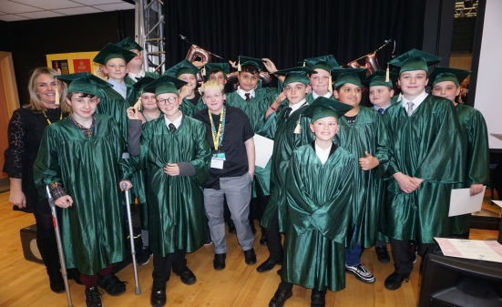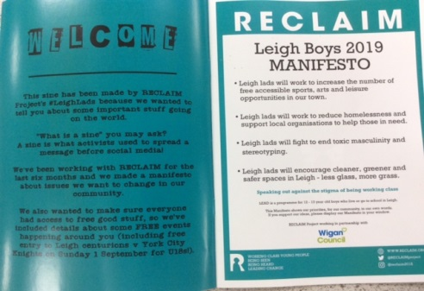

Congratulations to Y7 student Rhys Chadwick – who competed in the IBJJF competition in Ireland this weekend and we are delighted to confirm that Rhys won the gold medal – congratulations to Rhys, what a great achievement.

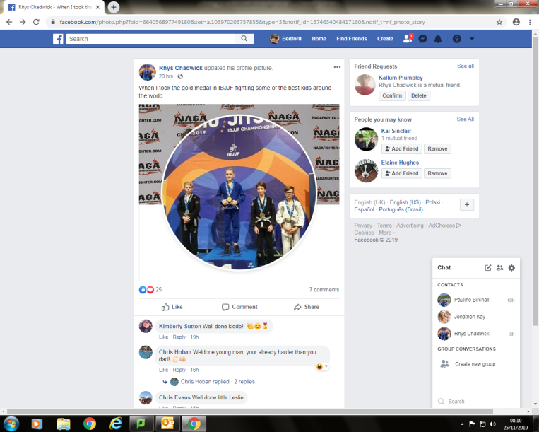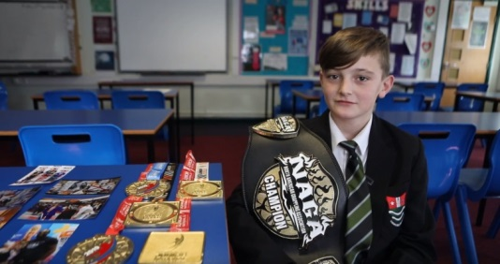

**Events & Activities w.e. 22nd November 2019**

**18th November – Visit to Jaguar/Landrover Halewood** - all KS4 Year 11 Design & Technology students visited and toured the production line of the Halewood site where Jaguar/Landrover currently build the Evoque & Landrover Freelander 2 models.  Accompanied by Jaguar staff of over 40 years’ service, the visit is made prior to students beginning their GCSE model construction of their final GCSE work to enable them to see for themselves the workings of the production line, industrial processes involved and the modern technology & 21st century robotics used in producing a vehicle from conception through to completion on the production line.

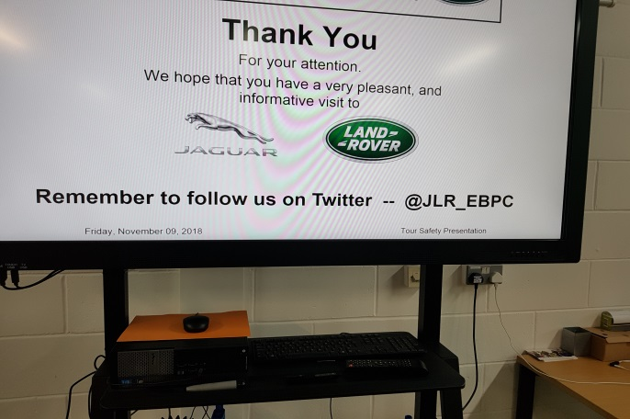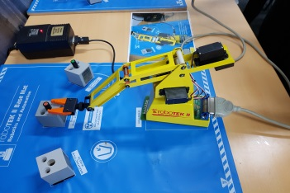

**22nd November - BBC Bite Size Schools Tour** in school.

Hosted by Radio 1 Presenter, Katie Thistleton, year 7, 8 and 9 students had an engaging assembly to promote the benefits of BBC Bitesize, which covers not only GCSE revision, but careers, mental health, relationship advice and more.

<https://www.bbc.co.uk/bitesize>.

Please encourage students to sign up to BBC Bitesize

There are ‘behind the scenes’ videos and articles on a huge range of careers, relating to creative roles – potentially including some of the panellists and hosts from the School’s event. The link is: <https://www.bbc.co.uk/bitesize/articles/z7dw47h>

Follow BBC Bitesize on Facebook, Twitter and Instagram: **@bbcbitesize**

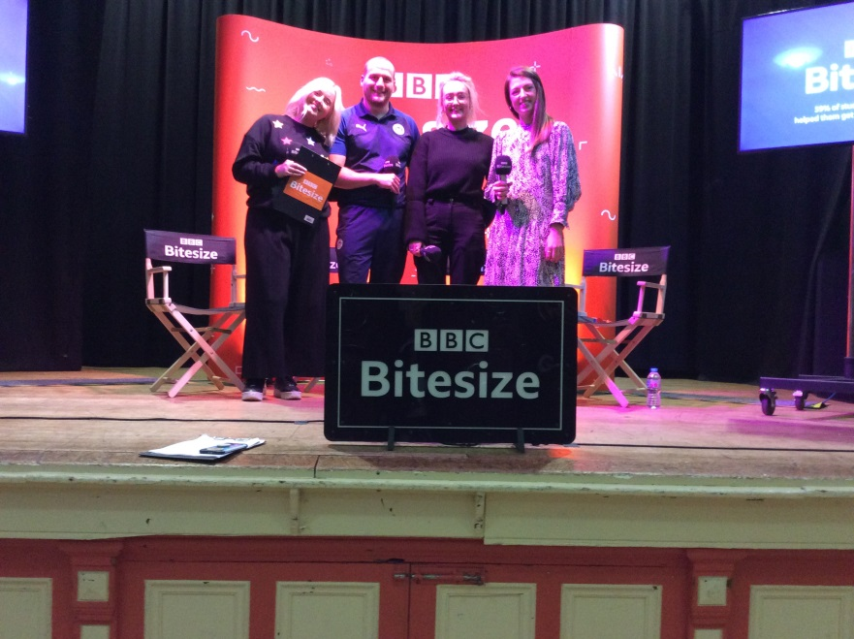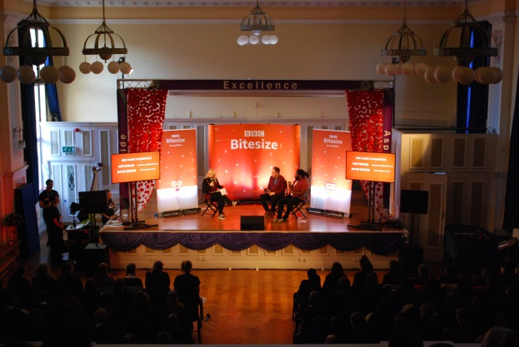

**21st November – Curious Incident in Schools Tour** was delivered in school to Year 8 students and GCSE Y9 and Y10 drama students. Video and photographs (courtesy of TheOtherRichard) can be viewed through the links below.

[https://www.youtube.com/watch?v=ivrTrvBKL5w&feature=youtu.be](https://urldefense.proofpoint.com/v2/url?u=https-3A__www.youtube.com_watch-3Fv-3DivrTrvBKL5w-26feature-3Dyoutu.be&d=DwMF-g&c=fRiKniiKXITijYtB4VcDn_uWvC72Sb0QJa4Lmnuhii0&r=3nj_uAWogIYOVotKGqpksbmqcl6S5i6G7m8RVlOuBRE&m=Wpose-gbOsjfpT_6H8I8XhyI9EfmLMnzSh6UAkDoHt4&s=tMTel2UjuJQ2u_H4e-W1DSXWpTE3BUPJkH2W3ErOPKk&e=)

<https://www.dropbox.com/sh/c390th5xzuibbal/AADWAd7SSDYoaWgFOrAH20J3a?dl=0>

**21st November - Graduation Evening for Class of 2019 leavers**, returned to school for their GCSE Certificates. Subject and special awards were also announced.

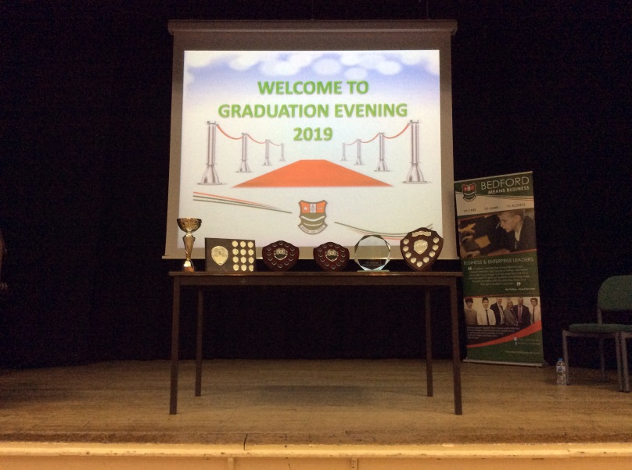

**22nd November – Program and Build Workshop**

Year 9 Computer Science students have had a fantastic time today taking part in the Program & Build workshops delivered by PrepareRobo. They built their own Derby Cars and used their programming skills to program the car to move and react against sensors.

One student said "I found this workshop very entertaining and educational at the same time! I think that this was my favourite workshop that I have done. It helped a lot with my understanding of coding and programming."

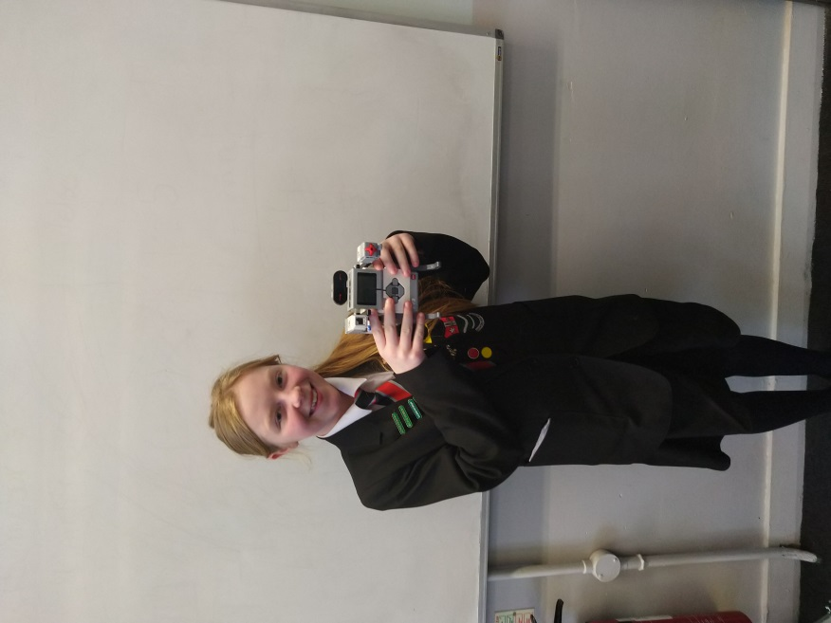

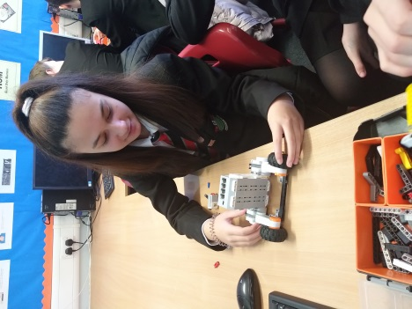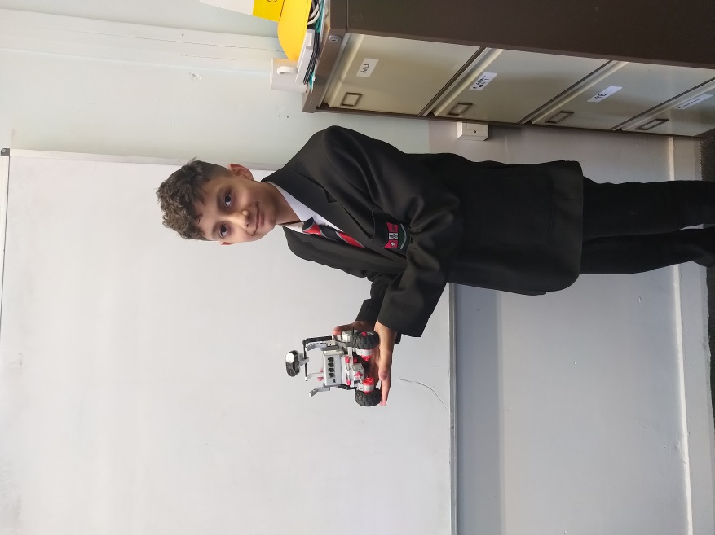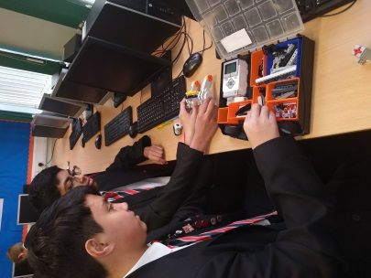

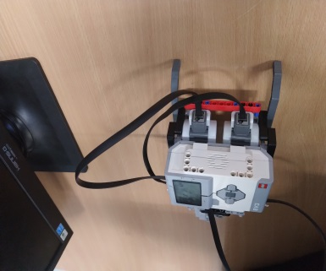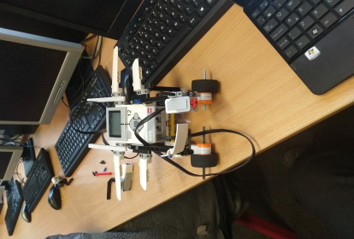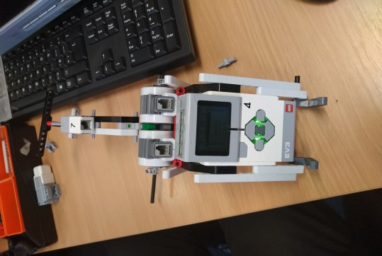

**Enrichment Day – Video and Press Releases** – the links are below:

**Video:** <https://www.youtube.com/watch?v=ChQOE98KIqs>

**Press releases:**

<https://www.leighjournal.co.uk/news/18031144.army-veteran-andy-reid-mbe-delivers-inspirational-talk-students/>

<https://www.wigantoday.net/news/people/injured-soldier-an-inspiration-for-borough-youngsters-1-10108821>

<https://www.theboltonnews.co.uk/news/northwest/18031144.army-veteran-andy-reid-mbe-delivers-inspirational-talk-students/?ref=rss>

**Christmas Charity Appeals:**

Year 7 Atherton and Leigh Food Bank

Year 8 Christmas Charity Appeal for Cystic Fibrosis

**3-5 Dec - Elf School Production**

Tickets are on sale but selling fast.

