EVENTS & ACTIVITIES W.E. 15TH NOVEMBER 2019

Please read below the weekly events and activities across school to celebrate the success of our students and showcase our business and partnership links.

To keep up to date as events and activities happen, please follow us on social media as below:

Facebook: bedfordhighschoollive
You Tube: bedfordhighschoollive – click on our Channel
Twitter: @bedfordhighsch
Instagram: brand new Bedford High School Instagram page @bedfordhighschoollive and Bedford Arts @Bedfordarts

Student success

‘Future Chef’ Competition: Y10 student Daisy Belshaw won the Local Schools Final at Worsley College in Walkden last Friday and she will be now be mentored by the Executive Chef of The Hilton Hotel on Deansgate in Manchester.

Further information about the competition - Mrs. Everitt & Mrs. Garbutt:
Year 10 Food students were given the opportunity, to enter a National competition called 'FutureChef'. Mike Plumb, a Chef from Wigan College selected 2 winners from our school heat, Madison Isherwood and Daisy Belshaw who then went on to compete at Worsley College. At the end of the 1 1/2 hours where a 2 course meal for 2 had to be prepared costing no more than £7, the 3 judges decided that Daisy would go on to the next round of the competition, the Regional Final in Preston at the end of January, 2020. Both girls got certificates for taking part but as part of her prize Daisy also won a Recipe Book and a mentor. 2 of the judges wanted to mentor Daisy but there could only be one mentor and that is James Yates, the Executive Chef at The Hilton Hotel on Deansgate in Manchester. We are extremely proud of both girls and what they accomplished. We hope Daisy enjoys her time working with the Chef at The Hilton and wish her every success in the New Year!
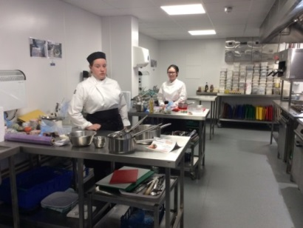
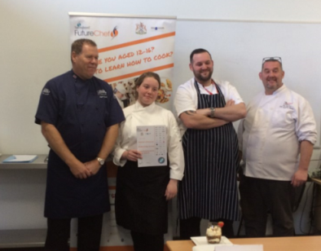
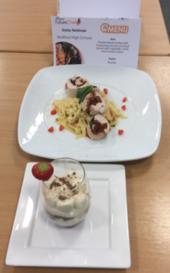
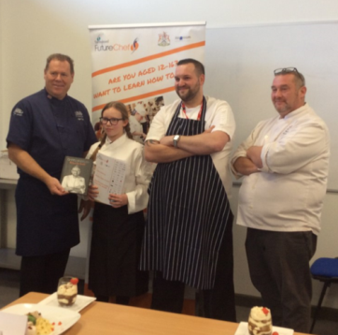

Former student, Keegan Moran, represented young people from Wigan & Leigh at the UK Youth Parliament’s annual debate in the House of Commons on Friday. Keegan was an active member of Youth Parliament during his time at Bedford and we are proud of his continued success.

Continued/…

Events & Activities w.e. 15th November

11th November - Our Year 7 Christmas Charity focus is Atherton and Leigh Foodbank. Warren Done from the Charity came into school on Monday morning to present to the Year 7s about the good work the foodbank does. It provides over 150 people with food each week, over a tonne of food! We are asking students to bring in whatever they can spare, emphasising that quality, nutritious food with long use-by dates (such as canned items) are much more beneficial to food bank users than sweets, chocolates or perishable food. Hygiene products like nappies, deodorants and shampoos are also very gratefully received. The closing date for food donations is Friday 6th December. Anything you can spare will go a long way towards helping others out at what can be a difficult time of the year. For further information visit the website:
https://athertonleigh.foodbank.org.uk/
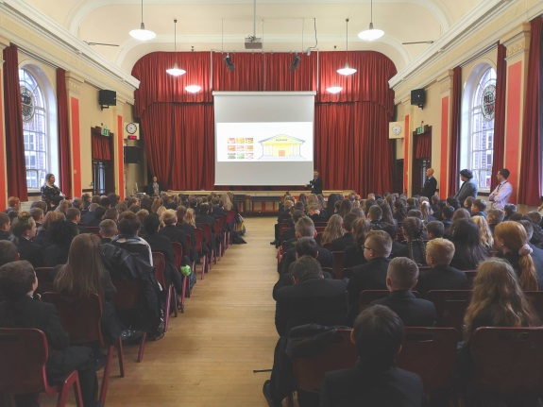

13th November - Y10 Religion and Citizenship students took part in an exciting and informative Masterclass led by the fantastic Dr David Torevell from Leeds Trinity University #leedsTrinity #BHSHumanities #christianity #Eduqas’.

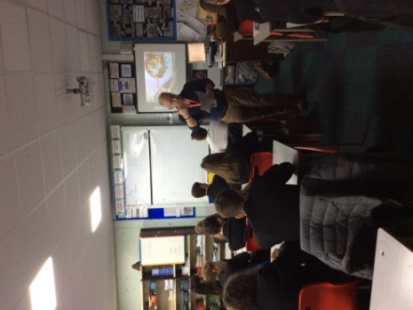
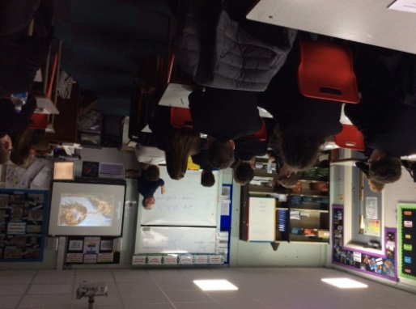
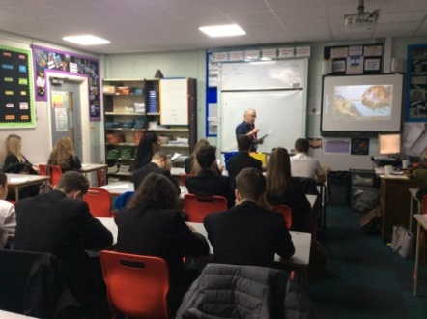

Continued/…

ELF the Musical – 3,4,5 December – tickets are on sale now. Please support this event.

