EVENTS & ACTIVITIES W.E. 20TH DECEMBER 2019

Please read below the weekly events and activities across school to celebrate the success of our students and showcase our business and partnership links.

To keep up to date as events and activities happen, please follow us on social media as below:

Facebook: bedfordhighschoollive
You Tube: bedfordhighschoollive – click on our Channel
Twitter: @bedfordhighsch
Instagram: brand new Bedford High School Instagram page @bedfordhighschoollive and Bedford Arts @Bedfordarts

16-17th December - Bedford Christmas Choir on tour in the community

Thanks again to the Expressive Arts Team, Bedford Choir were out in the community on Monday and Tuesday performing at various primary schools, nursing homes, retail shops and day centres. A fun time was had by all judging by the pictures below!
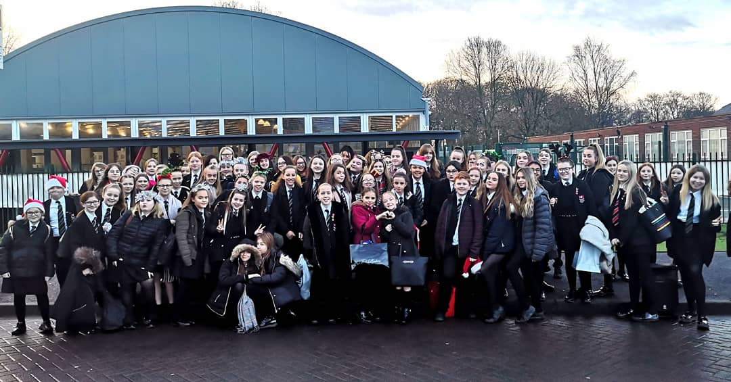
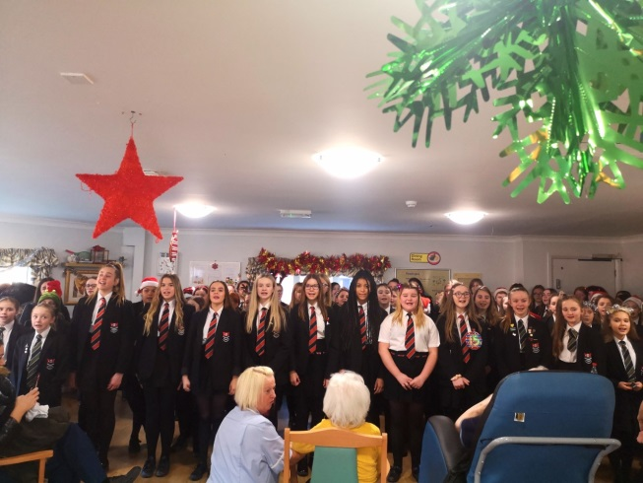
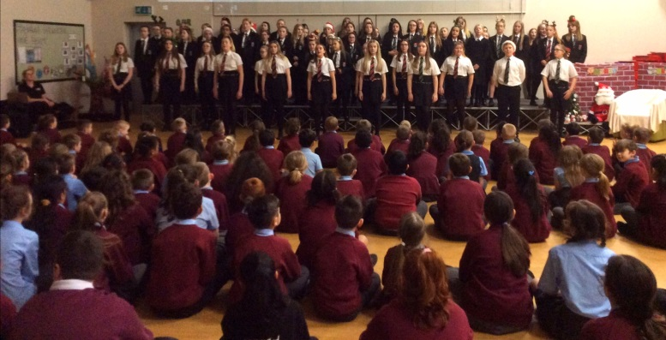
16-19th December - B&E Bedford Christmas Markets for Charity

B&E GCSE Students organised Christmas Markets at lunch time this week for charitable causes including: Team Trees to help the environment, Cancer Research UK and Macmillan Cancer Support.

18th December – Christmas Dinner Celebration Day

Christmas Celebration Dinner Day yesterday in the Bistro - great food and drink thanks to Aspens and entertainment including the staff band. Thank you to all staff involved in organising the day and serving students.

Thank you also to local businesses, Bedford staff and people in the community that kindly donated a prize for our student raffle as part of our Christmas dinner day. A special thank you to - Tasty Bite, Mia's Café, Cucina Café, Cineworld, Market Street Chippie, Mrs Harding, Pennington Plaice Fish and Chips and Ms McMullen.

Watch out for the film on you tube shortly.

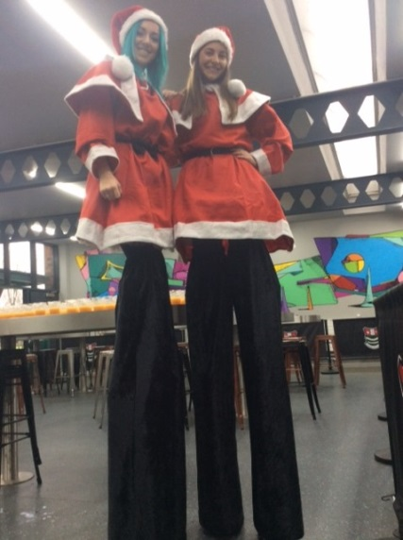
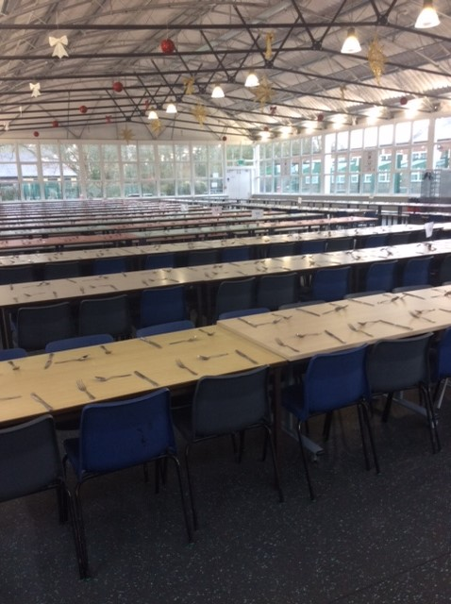

Year 8 Fundraising for Cystic Fibrosis Charity

£300+ and still counting has been raised by year 8 so far for their chosen Cystic Fibrosis Charity, with many activities including cake sales and a spacehopper competition for both staff and students. Well done to all students and staff involved.

School Partner (Maintel) wins large organisation ‘Learning at Work Week 2019 Impact Award’

Huge congratulations to Maintel on winning the Learning at Work Week 2019 Impact Awards. 12 year 8 students spent a day at Maintel with a focus on Women in Technology and our students did a fabulous presentation for Maintel staff (photos below). Link to the article with a photo of our students and a comment about the partnership
https://www.facebook.com/182598305735306/posts/468395840488883/?substory_index=0

