Bedford High School
Safeguarding Newsletter 2020

Designated Safeguarding Leads | Useful numbers / Websites
Rebecca Ramsden – DSL | - Childline 0800 1111
Helen Phillips – Deputy DSL | - Wigan Safeguarding Hub 01942 486262
Bridget Moss – Deputy DSL | - www.thinkuknow.co.uk
Paul McCaffery– Deputy DSL
Sue Critchley – Safeguarding Mentor

Welcome to the Spring Edition of Bedford High School’s Safeguarding Newsletter.

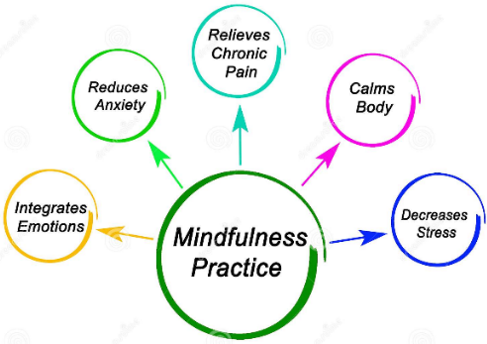
Personal Development
At Bedford, we strive to prepare all students for life in the modern world. During PSHE week recently, KS3 students have been exploring the benefits of team work and communication, future career pathways and the media.

Following the success of our recent Myriad project with Oxford University, we have also now introduced mindfulness to our form time programme. Mindfulness during form time offers our students a reflective period of time, helping individuals to prepare for the day, whilst supporting positive mental wellbeing.

Through assemblies, our focus continues to centre around our expected respectful behaviours and living without harm (to ourselves and in our communities). We have also explored how students can best prepare themselves for learning.

Online Safety In the News
This week, TikTok announced the latest app feature designed to support online safety. Parents will now be given tighter control over the app settings.
Launched in 2016, TikTok is a social media app designed to allow users to create short videos and live broadcast clips, predominantly with a music theme. According to Wikipedia "The app allows users to set their accounts as private, allowing only people they approve to view their content. Users can also allow either everyone or only their friends to send comments or messages to them, and react or duet with them".
However, the app has come under criticism for inappropriate content and bullying. It has also been linked to potentially dangerous internet 'crazes'.
With the use of TikTok on the rise among the 12 - 15 age group, it is definitely one to watch. With the creative potential that the app offers, it has a number of benefits too.

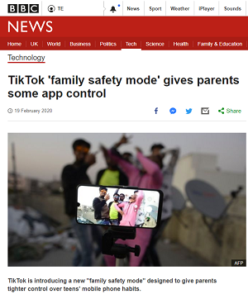
Online Safety Advice

Do you have a concern about your child’s safety online or would you just like to find out more about online safety? The ThinkUKnow website (www.thinkuknow.co.uk), offers a wealth of user-friendly information about online safety for young people, parents and schools.

If your child has been inappropriately approached online, or someone is trying to meet up with them, you should report this directly to CEOP. This may have happened in a chat app (e.g. Snapchat), message board, instant messenger or on a social networking site. It could be on a mobile phone, games console or computer and be in the form of messages, images or conversation over webcam. The important thing is that if an adult is making sexual advances to your child on the internet you should report it.
If you are concerned that your child is in immediate danger, call 999.

How do I make a report? You can make a report to CEOP using the CEOP Safety Centre (https://www.ceop.police.uk/safety-centre). You will need to complete an online form which will ask you for your contact details and information about what has happened.
If you want to discuss your concerns with someone first then call the NSPCC Helpline on 0800 800 5000.

Keeping Safe in the Community

According to recently published statistics for our local area, the second highest reported community issue to the police is that of anti-social behaviour.

Recognising the importance of being safe and keeping others safe when out and about, it is recommended that you speak to your son/daughter about safety and behaviour when out with friends. This is also an ideal opportunity to set boundaries and give reassurance that the door is open for them to speak to you about concerns or situations that they may find themselves in. Young people can often find themselves victim to peer pressure and may not feel they can ask for advice.

What is Anti-Social Behaviour (ASB)?
Anti-social behaviour is where the behaviour and actions of an individual or group causes, or is likely to cause:
- harassment, alarm or distress to any person of another household
- a person to feel personally threatened
- a public nuisance or detrimental impact upon the environment
- a detrimental effect upon the quality of life of an individual or the community as a whole

What can I do as a parent?
Young people often feel they are blamed as the main cause of anti-social behaviour; the stereotype arises largely from the fact that groups of young people often hang out on the streets or other public places. Certain behaviour, which is not always intended to cause nuisance, can be perceived by people in the community as ASB when it has an impact on their everyday lives.
It is recommended you talk to your child about ASB when the time comes that you let them venture out without you, in just the same way you would talk to them about staying safe. Explain how their behaviour will affect others and how it can be perceived, encouraging them to be mindful and considerate.

Before they go out, ask them:  ☺What they are planning to do?  ☺Where they are going?  ☺Who are they going with?  ☺What time, and how they will be getting home? | Tell them:  ☺To think about what they are doing  ☺Not to cause distress or annoyance  ☺Not to cause damage to property  ☺Not to put themselves or others in danger

Young people can also be the victims of crime and disorder:
  - Make sure they know how to stay safe
  - Make sure they know what to do if they are a victim of crime
  - Make sure they can contact an adult at any time and who it is
  - Make sure they know how to use the police 101 and 999 services

Support your child

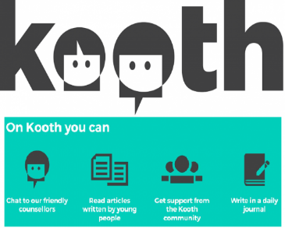
It is important to remember that it can be difficult for a child to come forward and speak to an adult. They may feel embarrassed or fear adults won’t understand. If you would like any advice on how to support your child, please ring school and speak to your child’s Pastoral Guidance Officer or the Designated Safeguarding Lead (Mrs Ramsden). You may also wish to signpost your child to www.kooth.com. Kooth is an online, confidential service, offering help and advice to young people regarding their emotional and mental health concerns. It is free to use and recommended by schools and other professional agencies in the borough.

