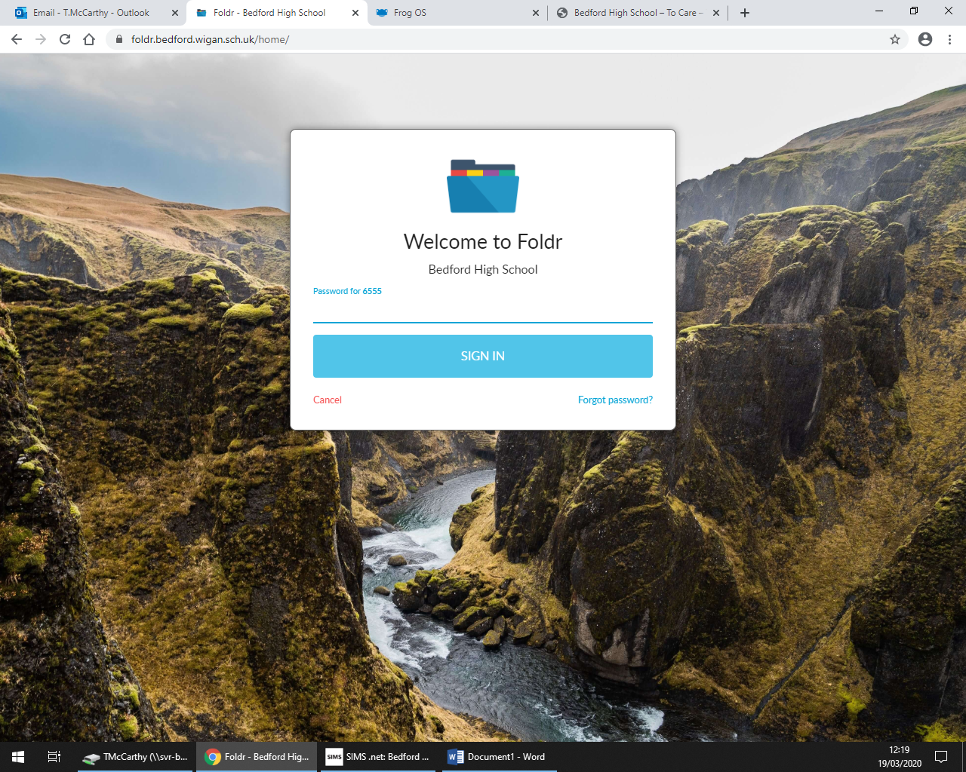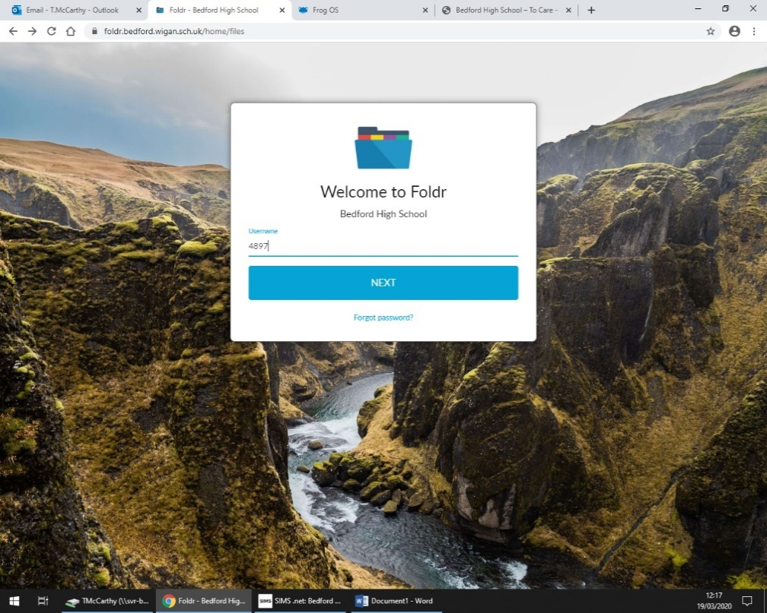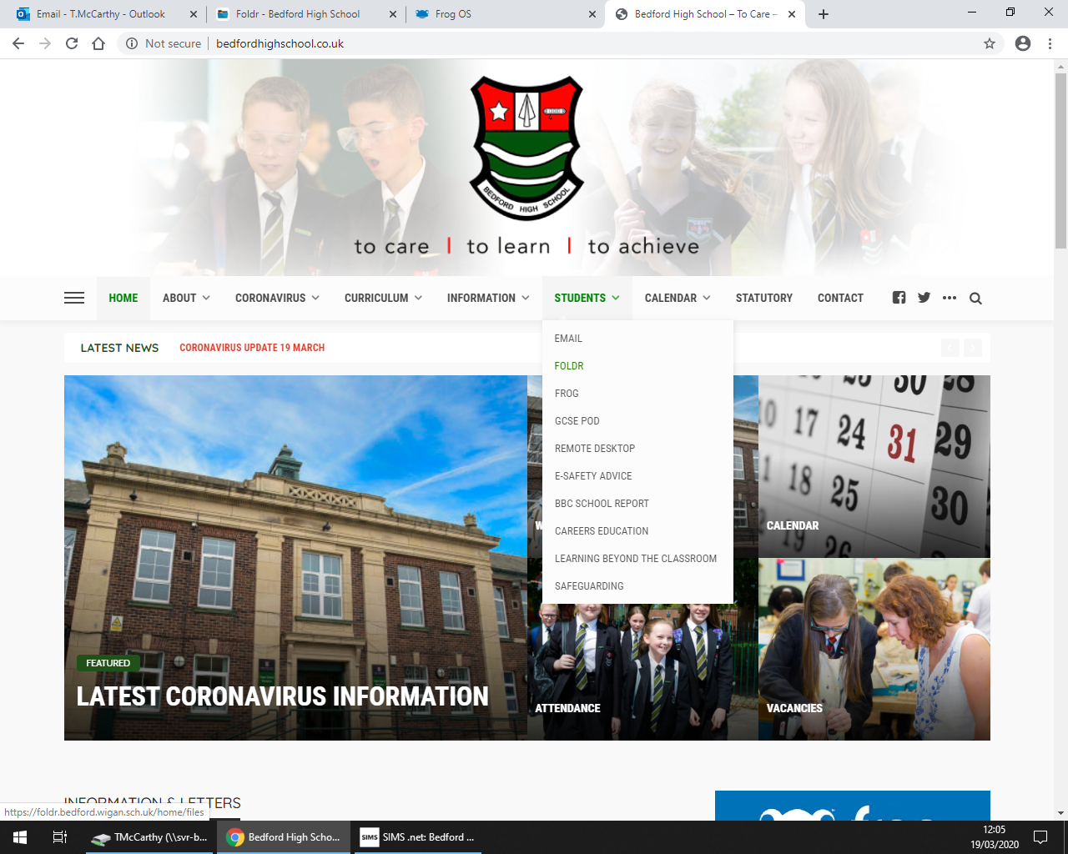

You can now enter your 4 digit login and then click next. Then enter your normal login password. You can now access all your folders from school.

Using the same student tab click on FOLDR this will allow you to access your school network and all of your work remotely from home.

Go to the Bedford High school website and click on the student tab here you can access your emails by clicking the email tab and logging in VIA your 4 digits @beford.wigan.sch.uk (example [4679@bedford.wigan.sch.uk](mailto:4679@bedford.wigan.sch.uk) ) use your normal password to log in.