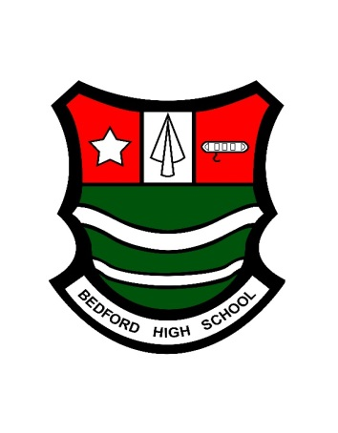

**BEDFORD HIGH SCHOOL**

**NATIONAL CAREERS WEEK – 2-7 MARCH 2020**

Facebook: bedfordhighschoollive

You Tube: bedfordhighschoollive – click on our Channel

Twitter: @bedfordhighsch

Instagram: @bedfordhighschoollive and Bedford Arts @Bedfordarts

NCW is a careers focus week. During the week in school, we aim to highlight the link between education and the world of employment to ensure students get an important insight to the future of work and learning. #NCW2020 on Twitter.

RBS are sponsors of national careers week and they have produced a guide to explain the different career pathways and opportunities within the RBS.

<https://www.careerkickstart.rbs.com/>

National Careers Week TV Channel - <https://www.ncwtv.co.uk/>

BBC Bitesize: <https://twitter.com/bbcbitesize>

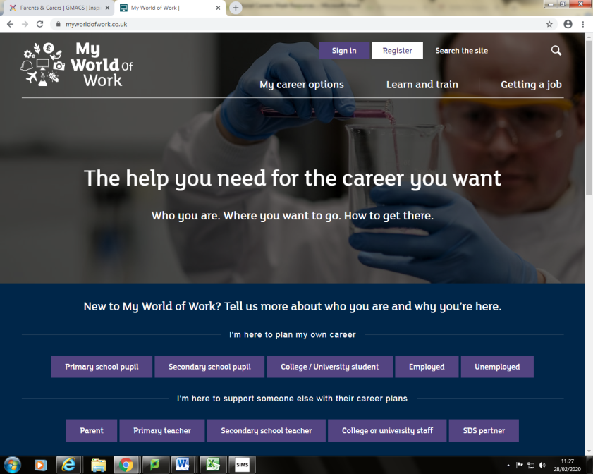**My World of Work** - a website to help students to choose their subjects at school.

<https://www.myworldofwork.co.uk/>

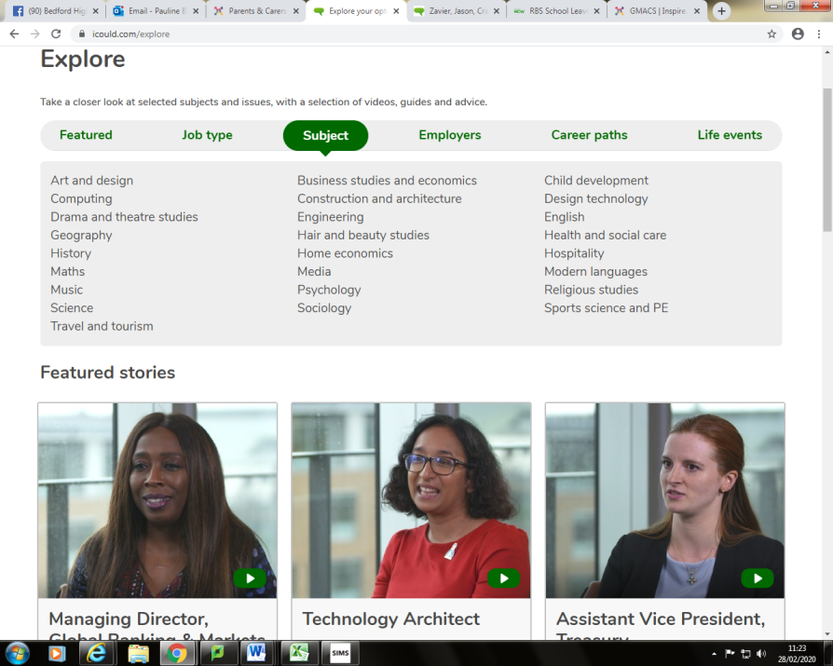**Icould website** – students can take the Buzz Quiz to find out what animal they are and explore careers through videos – by subject and job type. <https://icould.com/buzz-quiz/>

**Greater Manchester Apprenticeship and Careers Services Website**, launched recently by Andy Burnham, Mayor of Manchester. The website aims to inspire young people with the huge opportunities available to them in their future work in Greater Manchester. We will be rolling this out in school shortly.

<https://gmacs.co.uk/parents-and-carers>

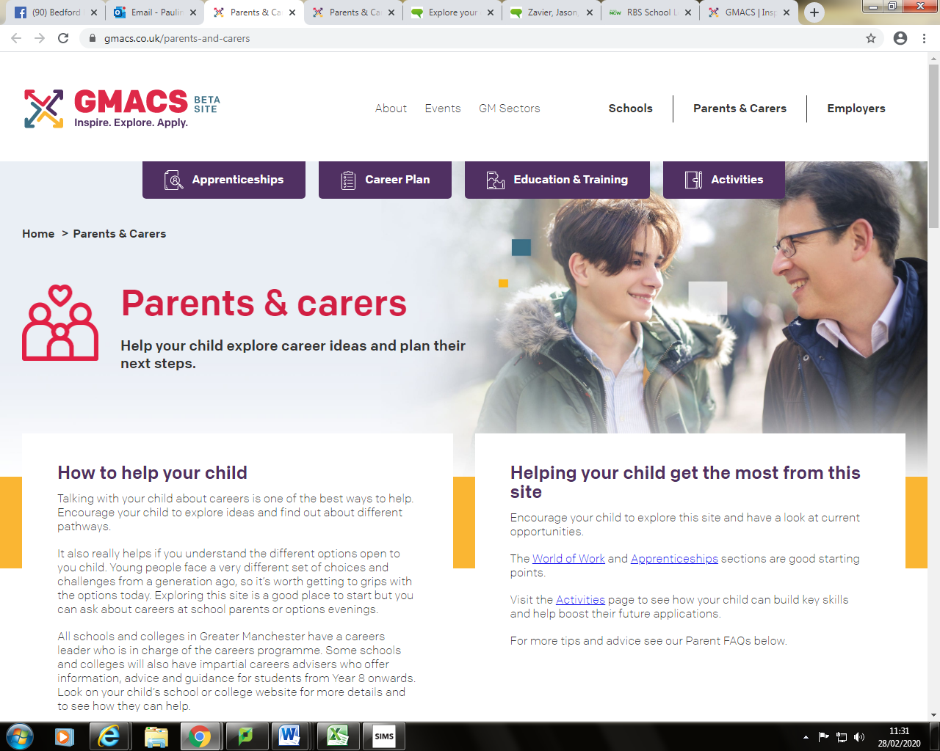

**CAREERS FOCUS - ENGINEERING**

CAREERS BUSINESS LUNCHES WITH STUDENTS: We aim to inspire students about their future opportunities in the world of work throughout their school years not just during National Careers Week. Our Business Lunches with students is one way and we were delighted to welcome former student and Mechanical Design Engineering Apprentice with Nuvia back into school on 12 February to deliver an Engineering Business Lunch. Cailey was a Grade 8 student who opted for an apprenticeship and in her first year was awarded Apprentice of the Year. We are very proud of Cailey's achievements. She was open and honest with students and provided an invaluable insight into an Engineering Apprenticeship in the Nuclear Industry, even showing the students some of her engineering drawings and tools she has made. Cailey was one of just 3 girls in a class of 45 at College and wants to break the stereotype and pass the message on that Engineering is not just for the boys. Take a look at [This Is Engineering](https://www.facebook.com/FollowWhatYouLove/?__tn__=K-R&eid=ARC8iwZNvWd1JEVt07-t12DNTv6P7ip7rAGsFFfrLcSCxCUgBV1c_WMPrmahLZWZoz5eQIVIpz4q4j1D&fref=mentions&__xts__%5B0%5D=68.ARAFMkA0UC35HpmKRojKfOC8utWoIxlFetLxpV8zxq4QSiQWjYzZQksAyBdhQeaHZS6IS24I5XHNA1aXgmQGSSvDGXHI_uBpENo4YphXv3eL-PLupGP3R5h-6zTJDbRN12vmJPlZhtzOQBNWjGeHY9rTCSwU5owccldOm7WNULA1WXcpGvPabxIY6c5Vkz5hdzBjNIbxSa4ATmsbBQ-RU_bZasWus5CVCNyZwFWMITHf4rdtfFjoayFRyyccc7dYSb8GdTMe6HDDrmG4PKG39iCxDOhpz1bm6BTJRPruX_iH6vAEsnoe6hhcPMp3tcMFgVXK8qPk6-w3KhNPY919J3gsMw) and follow [National Careers Week](https://www.facebook.com/NationalCareersWeek/?__tn__=K-R&eid=ARCZL7gwOVtSc4VLNG7w7Zm2CuoGM_pPual1QYlS6c2Qpptq28hm6mA0hQPzkcWRg_9Xc16DsS5Em-yc&fref=mentions&__xts__%5B0%5D=68.ARAFMkA0UC35HpmKRojKfOC8utWoIxlFetLxpV8zxq4QSiQWjYzZQksAyBdhQeaHZS6IS24I5XHNA1aXgmQGSSvDGXHI_uBpENo4YphXv3eL-PLupGP3R5h-6zTJDbRN12vmJPlZhtzOQBNWjGeHY9rTCSwU5owccldOm7WNULA1WXcpGvPabxIY6c5Vkz5hdzBjNIbxSa4ATmsbBQ-RU_bZasWus5CVCNyZwFWMITHf4rdtfFjoayFRyyccc7dYSb8GdTMe6HDDrmG4PKG39iCxDOhpz1bm6BTJRPruX_iH6vAEsnoe6hhcPMp3tcMFgVXK8qPk6-w3KhNPY919J3gsMw)<https://www.facebook.com/FollowWhatYouLove/>

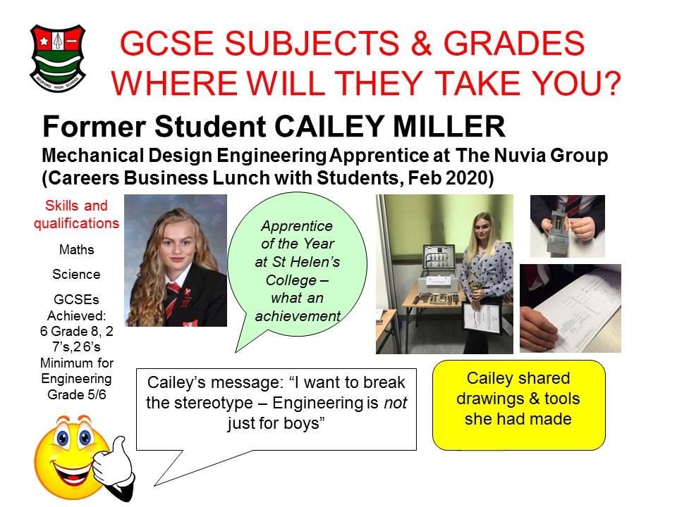

**CAREERS FOCUS – HEALTH**

National Careers Week - today's focus is Careers in Health. We were delighted, and honoured at this extremely busy time for the NHS, to welcome 4 members of the NHS team at our annual Careers Fair recently. We provide extensive opportunities throughout each academic year for students to have encounters with employers and employees to inspire our students.  
There are fantastic resources for students on the NHS Health Careers website: Students can take the 5 minute Quiz  
[https://www.healthcareers.nhs.uk/FindYourCareer](https://l.facebook.com/l.php?u=https%3A%2F%2Fwww.healthcareers.nhs.uk%2FFindYourCareer%3Ffbclid%3DIwAR1ZwAZGwK2Pob3x-DfEzA0wPzSfIn9uz2KVhTaOeETeQTGcj5RiSACm47Q&h=AT2_T8UVP0uQsjwXqBpQq4ToDbCq3qqC1iggOugrJAPJkP7JKAL3cL1d_1sQIBr_Osakx-ARlPkZag71g3d63gXbt2Aw8SZFuFbdyFRrYu6O9HZFMeuZRIRjxorC1DGANtBoyfJqm2Dk-0WtW9hxC6TEHqDbkeGajKWm0kiHso-lTw70-i4dNVm00rwVp1z_BuIk7kABktb9qOZD_FffdpspMqVqj3FKaYncbflqu3jU4OExsSKTni9PoRPKI22_6qZZRBojf5cxmNbm1O6LZhPVpk3BO9Ny1P_Whm8p6LpCGX1CJvup1NCCbi1-xOdJjDx1jyOPPSaNop501C-QNbw4ZGD8jWj3eifVxXyCsh_kSUO7IJsSUR8jPIX1DoIOS-FN04rixDcbV7aejVn5eIg1Pk4_w11JusDMsLMvh1KLLG1nBhiI89crPeb4Ktq5WewWXPsTs5FO-5XSi4_Kg8sDsosXUq9iuXo9tqaSfMEXFH5RxYqFX6uB3jiqwSBJnxOhvuKDjoeTfvlxTGaKcb2qV4eBqBlLJmgt0uL6xhse9f3ft_tfFsC0m22ux66DVdFGUC2RdUapkQnC-AGZodlCkGhMUof2pDhONv8TvnrElPeurWqzMrEvqbvfPFLc5ceN) and  
Explore roles in health [https://www.healthcareers.nhs.uk/explore-roles](https://www.healthcareers.nhs.uk/explore-roles?fbclid=IwAR0n_na4pHWrTivup_73dmE9e6w1jZh30dytna3b-p_GguYbpJUZrbyZ9ko)

<https://nationalcareersweek.com/new-site-template/sponsors/sponsors-nhs-health-careers/>

<https://www.healthcareers.nhs.uk/explore-roles>

<https://www.healthcareers.nhs.uk/FindYourCareer>

**CAREERS FOCUS – BUSINESS & FINANCE**

**KPMG – Our School Business Partner**

<https://www.kpmgcareers.co.uk/>

**PWC**

PwC are celebrating National Careers Week. In the spirit of celebrating all things careers, we wanted to share the great opportunities they have for school and college leavers taking a step into their future career.  
  
Traditionally, there’s only been one route when school or college comes to an end. University. Degree. Career. But things have changed. You don’t need a degree to launch a successful career in the business world. Many of PwC’s senior leaders joined without a university degree and have accelerated their career at PwC and beyond.  
  
Join one of PwC’s School and College Leaver programmes and you’ll earn a competitive salary and you could study towards a professional qualification and, in some cases, a level 4 apprenticeship.  
  
PwC have exciting roles available in their Tax and Operate teams. View their job search page [**here**](https://email.targetcareers.co.uk/rsps/m/K22Gui3H-kwArw8fNyr-aHEL6m8ElBvm-M-HVguohsU) for more details and how to apply.

[**pwc.co.uk/schools**](https://email.targetcareers.co.uk/rsps/m/K22Gui3H-kwArw8fNyr-aJqLOUEUAngIoFFseBatvYk)

**BDO**

<https://www.bdo.co.uk/en-gb/careers>

**CAREERS FOCUS – CAREERS IN CRAFTS**

[**www.craftscouncil.org.uk**](http://www.craftscouncil.org.uk)

**On Twitter follow @CraftsYouth**

[**www.discovercreative.careers**](http://www.discovercreative.careers)

**CAREERS FOCUS – MOTOR CAREERS**

Did you know there are over 150 job roles in the Retail Automotive sector, ranging from technical to non-technical roles, marketing, finance, customer service and sales? IMI Autocity will help you to choose the best role for you with information on all the jobs available, and help you plan your progression within the industry.    
  
Students: Join us in this exciting, diverse and fast-paced sector and find your [#MotorCareers](https://nationalcareersweek.us14.list-manage.com/track/click?u=4f1a07855a66527ededacb47d&id=a29bd2f9c1&e=559045c58e) today! Twitter tag #MOTORCAREERS

GUIDE FOR PARENTS:

<http://www.autocity.org.uk/index.php/parents/>

So now it’s time to find your dream job out of the 150 on offer to you.  Explore the roles on IMI Autocity.

<http://www.autocity.org.uk/index.php/explore-job-roles/>