COLLEGE APPLICATIONS:
INFORMATION FROM COLLEGES FOR YEAR 11 STUDENTS, PARENTS & GUARDIANS (UPDATED 9 JUNE 2020)
ANY CONCERNS
If any year 11 student has any concerns regarding their College Application or Apprenticeship, please get in touch with the College directly or Mrs Birchall through enquiries@bedford.wigan.sch.uk so that we can support you.
WIGAN & LEIGH COLLEGE
Wigan & Leigh College have produced a Steps to Success to ease the transition to those students starting at Wigan & Leigh College (including a virtual new student day) – click on the link https://www.wigan-leigh.ac.uk/about/coronavirus-update/year-11-applicants
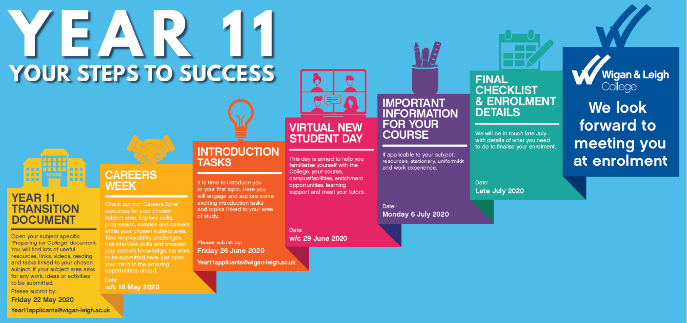
3 April: Year 11 students interested in an apprenticeship
Reminder Message to Y11 School Leaver Apprenticeship Applicants from Wigan & Leigh College. To maximize your chances of securing apprenticeship employment, please submit your CV, so that the College can market it to appropriate employers. CVs can be emailed in to the College at apprenticeships@wigan-leigh.ac.uk and you must do this by Friday 24th April 2020.
Important - We would like to reiterate that anyone applying for an Apprenticeship will be supported in finding employment as an apprentice and contact will be made with you if an employer within their chosen subject has a vacancy. The College is however aware that there may be a reduction in the number of apprenticeship vacancies as a consequence of the current situation. As an Apprenticeship applicant, you will have a place reserved on a full-time study programme if you are unable to find an employment vacancy prior to starting at College. Please also note that if you miss the deadline for CV submission, you can still look independently for employment and contact the College if you are successful in finding an employer.
Wigan & Leigh College bridging the gap resources are now available for your Year 11 to access via our website:
https://www.wigan-leigh.ac.uk/about/coronavirus-update/applicants
Please scroll down the page to the Year 11 Applicants section.
The curriculum documents will help Year 11 students prepare for College and their post 16 study.
If students have applied and had their interview – their place is safe and secure for September. Any students who have applied and not had an interview as yet, please do not worry, we will be carrying out telephone interviews over the coming weeks. Students can still apply through online applications at this time, but if you have any issues with accessing the internet from home – this can be done over the telephoned, please email Mrs Birchall via enquiries@bedford.wigan.sch.uk and we can arrange a telephone appointment. Latest information with regard to Coronavirus updates for applicants via the following link:
https://www.wigan-leigh.ac.uk/about/coronavirus-update/applicants
Key points from the Anna Dawe, Principal of Wigan & Leigh College
Year 11 School Leavers – Their place for September 2020 is safe
The impact of the methodology for awarding GCSE grades is not yet known but we are already committed, where appropriate, to looking at a wider picture than those single grades for our applicants.
When GCSE grades are issued, students will be able to work with the College admissions team to ensure they are on the right course at the right level. Where students may have missed the level of course they applied for, other factors may be taken into consideration such as predicted grades, discussions with a student’s previous school and progress made during the initial weeks at College.
Anyone applying for an Apprenticeship will be supported in finding employment as an apprentice and contact will be made with students if an employer within their chosen subject has a vacancy. The College is however aware that there may be a reduction in the number of apprenticeship vacancies as a consequence of the current situation. Apprenticeship applicants will have a place reserved on a full-time study programme if they have been unable to find an employment vacancy prior to starting at College.
If students have not yet had an admissions interview for the College, our Admissions Team will be in contact via telephone shortly.
The College will ensure that we are kept up to date over the coming months and if students require anything further regarding their application and place at the College, they can contact the Admissions team at applications@wigan-leigh.ac.uk
Student support and resources for preparing for college will follow shortly and we will continue to work closely with you at this uncertain time.
BOLTON COLLEGE
It is vital that we have up to date mobile numbers and email addresses for all our applicants. Changes can be made by emailing admissions@boltoncc.ac.uk

June 2020: Link to you tube channel contains video clips to get a taste of life at Bolton College

https://www.youtube.com/user/BoltonCollege/videos

May 2020: Initial Assessment / BKSB – the decision has been made to cancel the sessions which were due to run in June and July. Anyone who has booked has received a cancellation email.

New Student Event – it has also been decided to cancel this event and I will be contacting people who have booked on to it to explain the situation. We will be working on something to share with our new learners before they join us at the start of their course and I’ll let you have more information when I can.

General Open Event – this was due to take place on Saturday 13 June but has now been cancelled too.

Telephone Interviews – these are continuing but we have a problem with young people not answering their telephone phones or not updating us with new numbers. Y11 students wishing to go to Bolton College, should check Bolton College have the correct contact details for you and they have been in touch with you. If you have not heard from the College please contact Mrs Birchall at Bedford High School, enquiries@bedford.wigan.sch.uk.

Bridging Resources – have been emailed to all young people who have applied to us and we think are still interested in joining us next academic year.

BOLTON SIXTH FORM
21 May 2020: The next phase of the transitional work for year 11’s will be available on their website from Monday 25th May, it will be uploaded on Sunday evening.
www.bolton-sfc.ac.uk and from the main menu select the drop down for >Courses >Transitional work for Year 11’s, we will be updating that page on the 24th of each month with new tasks for them.

Just to let you know we will be holding a Virtual New Student Day for Year 11s on Friday 3rd July and more info will follow early June.
UPDATE 24TH APRIL: The Sixth Form Bolton have now loaded some work on the website that Year 11’s can be working on. If you go onto our website - www.bolton-sfc.ac.uk and then from the main menu select the drop down for >Courses >Transitional work for Year 11’s. Not all subjects are completed yet so more information will be added next week then following on from that we will be updating that page on the 24th of each month with new tasks for year 11’s.
Please do not worry about your place at The Sixth Form for September 2020. If you have already been interviewed and offered a place, your enrolment interview will take place in August as normal. If you have not yet been interviewed, we will interview you later in the academic year and we will contact you with details about this as soon as we can.
ST JOHN RIGBY COLLEGE
An Email and letter to applicants regarding additional materials and New Student Day:
Dear Students, Parents and Carers
I hope that you and your family are keeping well under the difficult circumstances that we are all experiencing. Following recent government announcements, we are now making some arrangements at SJR for groups of students to be able to attend College during the last half term whilst still adhering to social distancing guidance. It is good to see that there is some gradual easing of lockdown but it is also clear that over the coming weeks and months we will still be having to maintain safe distances from one another. Therefore, regretfully we have decided that it will not be possible to hold our New Student Day for you on Monday 29 June. I know that New Student Day 2020 was a day that many of you will have been looking forward to in order to provide a reassuring milestone on your transition from school to college. With this in mind we have developed a virtual SJR New Student experience via our SJR New Students’ Hub. The ‘hub’ is now live and the information that you need to access it is as follows:

SJR Applicant Hub link: http://sjr.ac.uk/newstudentshub.asp
Password: SJR2020

Through this hub you can access a wealth of resources to support your transition to college and enable you to have a flying start into your courses in September. Included in the hub are the following:
• ‘Bridging’ and prior learning materials for SJR courses and Electives
• Details regarding transport to and from college • Further information on the outstanding support offered to SJR students
• An interactive tour of the college site
As always, if you need further information, support or help in anyway please do not hesitate to contact the college via newstudents@sjr.ac.uk. I would like to take this opportunity to reassure those of you who have been contacting us to check that you are still able to accept places at more than one college that the answer to this is, yes, you can.
It has always been the case that you do not need to make your final decision about your college or your courses until you receive your results at the end of August and enrol at your chosen college. Given that SJR is ‘outstanding’, we do hope that your choice will be SJR and we will keep in contact with you and provide support through the SJR New Students’ Hub in the expectation that this will be the case.
Best wishes, stay safe and I look forward to seeing and working with you again soon. Peter McGhee
Students can challenge themselves to do some ‘bridging work’ in the subjects that they are considering studying at college, they can access some additional work via this link: http://sjr.ac.uk/y11_subject_guides2.asp
WARRINGTON & VALE ROYAL COLLEGE
May 2020: Virtual Open Week Monday, 1st June to 5th June but you need to register your interest. https://www.wvr.ac.uk/new-events/events/school-leavers-virtual-open-week/
We are still accepting applications for September 2020. Students can apply online by searching for the course they are interested in on our 'study with us 'webpage (https://www.wvr.ac.uk/courses-and-apprenticeships/). If they find something they like, simply click on the ‘apply for this course’ button. They can then easily create an account online and apply for the course they are interested in. Key points from their letter which will be sent out:
If you are awaiting a college interview, please note that these have been postponed. We are in the process of looking at telephone interview arrangements and will contact you directly as soon as these are confirmed.
Anyone applying for an apprenticeship will continue to be supported in finding employment as an apprentice and you will be contacted if an employer within your chosen subject has a vacancy. As a consequence of these uncertain times, the college anticipates a reduction in the number of apprenticeship vacancies, however all apprenticeship applicants will have a place reserved on a full-time course if they have been unable to secure an apprenticeship vacancy prior to September.
Moreover, following the government's announcement about exams and qualifications, please rest assured that your application will not be in any way disadvantaged because of the exceptional circumstances in which qualifications are having to be awarded this year.
Please expect further updates over the coming months, as we aim to keep you as informed as possible. If you have any further questions regarding your application and place at college, please do not hesitate to contact our admissions team on applications@wvr.ac.uk.
WINSTANLEY COLLEGE
Winstanley College have emailed all students who have applied and had an interview offering them a guaranteed place and that they need to accept the place by the 1st May.

Any students who have not applied at all then they will go on a waiting list.

Winstanley College bridging materials for the Year 11s who want to study A Levels/extended certificates with them – click on the link to subject guides.

http://www.winstanley.ac.uk/y11-subject-guides/

THE MANCHESTER COLLEGE
We are excited to launch a brand new resource for schools and are proud to introduce our ‘Connect2College’ programme.

The programme will ensure their journey from school to the College is as smooth as possible and includes some useful resources, curriculum activities and quizzes for pupils to get involved in from home.

We would encourage your pupils to access: https://www.tmc.ac.uk/student-life/connect2college

