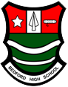
FROG- Guidance for Parents.
What is Frog?
Frog is the Virtual Learning Network (VLN) that Bedford High School uses to support our learning and communication. Frog is accessible for staff, students and parents.
What can I see on Frog?
The FROG Parent Portal provides you with lots of useful information about your child’s education. Log on today to check the following:
  - Homework - You can view all homework that has been set for your child.
  - Attendance - See weekly attendance marks to check your child is on time and in school.
  - Behaviour - See any positive reward points issued and any behaviour incidents.
  - Key notices- Keep updated with school news, events and information. Our social media feed is also live on Frog.
  - Screening- you can track your child’s progress on Frog as all reports will be available to you on Frog.
  - Other features- your child’s timetable and Frog Messaging allows for staff to send you messages regarding learning, trips, events or other important information.

Useful learning resources on Frog.
FROG provides your child with lots of useful information and resources such as the
- Exam Area where students can find information about their Exams.
- Revision Area – Explore guidance and resources.to help get the best results possible in their exams.
- Knowledge Organisers site- all Knowledge organiser for all subjects are accessible on Frog.
- GCSE POD – Online Podcasts and video files that can be downloaded and accessed on any device at any time.
- Careers- students can gain access to their Employability passports as well as lots of career guidance and support. We also signpost our many Career events on this page too.

How do I access Frog?
- Click the FROG logo from the school website. (www.bedfordhighschool.co.uk)
- Enter your username and password. If you have forgotten your login details you should visit the school website homepage to access the link to ‘Need your Frog login’ which can be found by scrolling down the homepage to the Frog section.

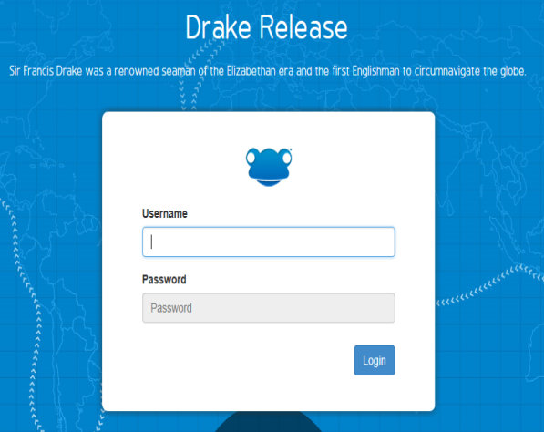

Further guidance and support on using Frog.
Further guidance and support can be found on the Homepage of the school website. A video tutorial explaining how to navigate around Frog can also be found there. If you encounter any technical problems with Frog you should email: frogsupport@bedford.wigan.sch.uk

Checking Homework on the new Frog App
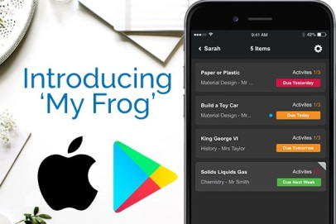
The easiest way to get notified with your child’s homework is to use the ‘MyFrog’ app which can be downloaded from the App store. With one touch you will have access to all your child’s homework and when it is due.

We would like to take this opportunity to thank all parents for their continued support. We recognise that with excellent parental support we can achieve so much more for our children.

