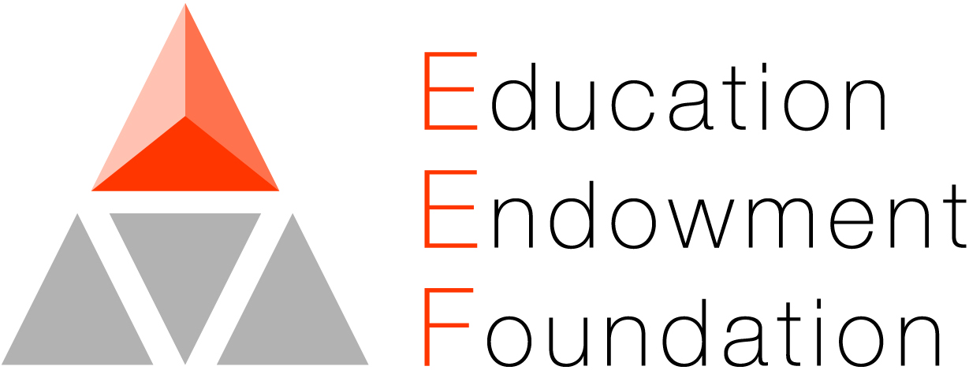

04 November 2020

Dear Parent/Carer,

**Research Study – FLASH Marking in English**

We are writing regarding a national research project that the English Department at your child’s school have been participating in for the last two years. FLASH Marking is a new approach to marking and feedback in English. In order to assess the impact of this initiative, GCSE data from your child’s school will be used to understand whether there is a difference between schools who have used the FLASH Marking approach and those who have not.

Further details about the study can be found on the following website: https://educationendowmentfoundation.org.uk/projects-and-evaluation/projects/flash-marking/

Your child’s school is a ‘control’ school. This means that they will not be using the FLASH Marking approach this year, but will be continuing with the school’s usual methods of assessment and feedback. The Head of English will be able to provide more details on this should you require them.

To help us with this research your child’s school will pass on some basic data. The information which your child’s school submits for the analysis to be carried out will include your child’s name, date of birth and Unique Pupil Number (UPN). The data collected will be linked with information from the National Pupil Database (NPD) and shared with the Department for Education, the EEF’s archive manager and, in an anonymised form, with the Office for National Statistics and potentially other research teams. Further matching to NPD and other administrative data may take place during subsequent research.

Your child may also be asked to take part in a short survey about marking and feedback. Information from this will be submitted directly to the evaluation team, and will be processed and shared as described above.

All pupil and assessment data will be treated in the strictest confidence and will never be made public. No individuals or schools will be identified. The data for your child’s school will be analysed anonymously, together with data from other schools, and no individual pupils or schools will be named in any reporting of these study. The study is compliant with GDPR legislation and has been approved by Durham University Ethics Committee.

The published privacy notices for this project can be found here: https://www.dur.ac.uk/education/research/groups/?mode=project&id=1014

We hope you will support this important study. If you are happy for your child’s information to contribute to this project, you do not need to take any further action. If you do not wish for us to use your child’s data, you can opt out by contacting the Lead Evaluator using the contact details below. Your child will not be disadvantaged in any way. If you have further questions about the project or the evaluation, please do get in touch via the email address below.

Yours faithfully,



Dr Rebecca Morris, Lead Evaluator

University of Warwick

Email: Rebecca.e.morris@warwick.ac.uk