Pupil premium strategy statement – Bedford High School

The Pupil Premium is additional funding which is allocated to schools based on the number of pupils who have been eligible for free school meals (FSM) at any point over the last six years (known as ‘Ever 6 FSM’). The Pupil Premium is aimed at addressing the current underlying inequalities which exist between children from disadvantaged backgrounds and their more affluent peers.
The Pupil Premium also provides funding for looked after children, adopted children and the children of service personnel.
Funding rates for the 2024 to 2025 financial year
This table shows how the pupil premium grant is allocated to schools and local authorities in the 2024 to 2025 financial year, based on per pupil rates.
Funding criteria | Amount of funding for each primary-aged pupil per year | Amount of funding for each secondary-aged pupil per year | Funding is paid to
Pupils who are eligible for free school meals, or have been eligible in the past 6 years | £ 1,480 | £ 1,050 | School
Pupils previously looked after by a local authority or other state care | £ 2,570 | £ 2,570 | School
Children who are looked after by the local authority | £ 2,570 | £ 2,570 | Local

This statement details our school’s use of pupil premium funding to help improve the attainment of our disadvantaged pupils.
It outlines our pupil premium strategy, how we intend to spend the funding in this academic year and the outcomes for disadvantaged pupils last academic year.

School overview
Detail | Data
Number of pupils in school | 1112
Proportion (%) of pupil premium eligible pupils | 36.51%
Academic year/years that our current pupil premium strategy plan covers (3-year plans are recommended – you must still publish an updated statement each academic year) | November 2024-November 2027
Date this statement was published | November 2024
Date on which it will be reviewed | November 2025
Statement authorised by | Mr P McCaffery
Pupil premium lead | G Calwell
Governor / Trustee lead | Lynn Hayes

Funding overview
Detail | Amount
Pupil premium funding allocation this academic year | £ 391 350
Pupil premium funding carried forward from previous years (enter £0 if not applicable) | £0
Total budget for this academic year  If your school is an academy in a trust that pools this funding, state the amount available to your school this academic year | £

Part A: Pupil premium strategy plan

Statement of intent
Our intention is that all students, irrespective of their background or the barriers they face, make good progress and flourish so that they become effective citizens who are ambitious and employable. The focus of our pupil premium strategy is to ensure that we offer high quality provision for our pupil premium students so that they have an equitable education.
We recognise the potential and varied challenges that Pupil premium students can face. We recognise that their barriers are not just economic but can also be cultural, social and health related. The activity we have outlined in this statement is designed to support their needs, regardless of whether they are disadvantaged or not.
High-quality teaching is at the heart of our approach, with a focus on areas in which disadvantaged pupils require the most support. This is proven to have the greatest impact on closing the disadvantage attainment gap and at the same time will benefit the non-disadvantaged pupils in our school. Implicit in the intended outcomes detailed below, is the intention that non-disadvantaged pupils’ attainment will be sustained and improved alongside progress for their disadvantaged peers.
Our strategy will continue to consider where additional support is required for pupils who need reading intervention. We know that reading can be a significant barrier for disadvantaged students which is why this is a key part of our strategy. We will endeavour to ensure that all students, including Pupil Premium students, have a reading age that does not fall below their actual age.
Our approach will also be responsive to common challenges and individual needs, rooted in robust diagnostic assessment, not assumptions about the impact of disadvantage. The approaches we have adopted complement each other to help pupils excel. To ensure they are effective we will:
- ensure disadvantaged pupils are challenged in the work that they’re set
- act early to intervene at the point need is identified.
- adopt a whole school approach in which all staff take responsibility for disadvantaged pupils’ outcomes and raise expectations of what they can achieve
We want our students to be equally enriched with the extra-curricular opportunities that non-disadvantaged students benefit from. This is why we will support disadvantaged students with economic barriers which could face accessing cultural school trips.
We have used internal data and external evidence to support and inform our challenges and strategies.

Challenges
This details the key challenges to achievement that we have identified among our disadvantaged pupils.
Challenge number | Detail of challenge
1 | We want to narrow the attainment gap between disadvantaged and non-disadvantaged students. The national picture indicates that the gap has widened since Covid. Although our attainment gaps are narrowing, our PP students are still making half a grade less progress compared to Non-PP students.  Class of 2024 outcomes:  Progress 8:  Non PP -0.06  PP –0.57  Research tells us that the largest gains in attainment and progress can be made from high quality teaching. As the ‘EEF Guide to Pupil Premium’ recommends, ‘there is a need to ensure that we have a highly effective teacher is in front of every class, and that every teacher is supported to keep improving.’ The challenge is to ensure that our teachers are upskilled, developed and resourced so that our PP students benefit from consistently high-quality learning.
2 | We want to ensure that all learners leave school as confident and competent readers. Evidence from the EFF shows that three quarters of schools in England state that low-reading levels is one of the biggest challenges affecting socio-economically disadvantaged pupils’ academic achievement. Nationally, Key Stage 2 Reading Attainment headline figures for 2023/2024 have the disadvantage gap at 3.12.  Year 7 2024/2025 cohort – 25% of PP students failed to meet expected reading standard at KS2. We want to reduce this percentage throughout KS3 by offering intensive and specifically designed reading intervention to ensure that all PP students start KS4 reading in line with their non-PP peers.
3 | Attendance to school of PP students is below that of the rest of the school. This reduces their hours in school and causes them to fall behind. In 2019 the P8 Score for PP students with high attendance (96% +) was -0.19. The P8 score for PP students with attendance between 92-95% was -0.7
4 | Pupil premium students can face multiple and varied barriers that can prevent them from making the same progress as Non-PP students. We know from the research carried out by Lee Elliot Major in his work, ‘Equity in Education’ that disadvantaged students can face educational, cultural, social and emotional barriers as well as economic ones. PP students do not always have the support in place in these areas.

Intended outcomes
This explains the outcomes we are aiming for by the end of our current strategy plan, and how we will measure whether they have been achieved.
Intended outcome | Success criteria
To have highly effective teachers in every classroom. | KS4 performance measures demonstrate that disadvantaged students achieve an average Attainment 8 score of more than 36. The attainment 8 score will have further narrowed between PP and non-PP. This attainment gap will also be evident in English and Maths. Our Quality assurance indicates that all teachers are meeting our high standards. There is a developmental plan in place for teachers when standards are not being met so that immediate action can be taken to support the relevant staff.  CPD and Growth Plans indicate that practice and expertise has improved.
To have systems in place that allow for the diagnostic testing of all Year 7 students to ensure the early identification of students requiring literacy support.  To provide all struggling readers with specific, tailored reading interventions that enables them to become confident and competent readers who are reading at or above national benchmark by the end of KS3. | All students identified as struggling readers in Year 7 diagnostic testing are reading at or above national benchmark by the end of KS3.  Termly testing data to show reading age improvements across terms and years  Quality assurance of reading interventions indicates that intervention practices are delivered with fidelity and are supporting students to make rapid progress in their reading.
To achieve and sustain improved attendance for all students, particularly our disadvantaged students. | Sustained high attendance by 2026/27 demonstrated by:  - the overall unauthorised absence rate for all pupils being no more than national average and the attendance gap between disadvantaged pupils and their non-disadvantaged peers being reduced to at least pre-2019 levels.  - the percentage of all pupils who are persistently absent being in line or below national average and the figure among disadvantaged pupils being no lower than their peers.
We want to remove the Cultural Social, Emotional and Educational barriers that PP students can face. We want to do this in a systematic way that offers early intervention. | The EEF cite that involvement in arts-based learning can boost achievement in non-arts subjects, so work around the extra-curricular provision at Bedford will continue with particular emphasis on engaging PP students. 40% of all students involved in arts-based activities to be PP.  Cultural opportunities will be offered at a lower cost to PP students who score red on parent profiling where possible.  Parent profiling to work to engage hard to reach parents to attend school events and in particular parents evening. 75% attendance to parents evening to be the target.  The Triage room will engage students with disadvantaged levels of engagement or who find emotional regulation difficult at times, with numbers of PP students using the room reducing over time.  The Pastoral in Focus meetings pinpoint the students who need extra support every fortnight with a focus on PP students every 8 weeks. These sessions also act as extra bespoke training for pastoral colleagues.

Activity in this academic year
This details how we intend to spend our pupil premium funding this academic year to address the challenges listed above.

Teaching (for example, CPD, recruitment and retention)
Budgeted cost: £ [insert amount]
Activity | Evidence that supports this approach | Challenge number(s) addressed
Implementing Bedford High School’s Professional Growth CPD Programme. The new Professional Growth programme is designed to meet the needs of staff, students and school priorities. We will grow the knowledge and skills of our staff so that they can maximise their own potential whilst unlocking our student’s potential. As part of this, we will ensure that PP (under-resourced) CPD is in place for all teachers. The CPD will focus on the following:  1.Greater awareness of who our PP (UR) students are. Prioritising the PP students, ‘Our first and second thought;.  2. Building confidence and success rate  3. Teachers reaching out and connecting with parents.  4.Developing an Equity mindset: increasing awareness of Under-resourced student’s barriers and our unconscious bias.  4.getting more out of HW and breaking down their barriers. | We know from Viviane Robinson’s research that the most effective way that leaders can improve outcomes for young people is to focus on professional development.  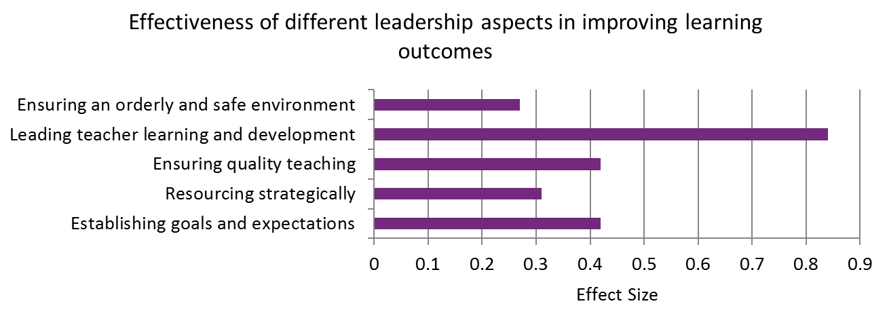  We know from the Sutton Trust that the difference between the effect of poor teaching and that of highly effective teaching is just under half a year’s extra progress for most students. Those from disadvantaged backgrounds are particularly affected as they stand to benefit even more than their classmates from effective teaching, but similarly they are also more sensitive to poor teaching. This highlight the need to ensure that high quality teaching is widespread.  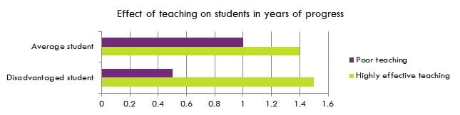  We know from the EPPI-Centre Studies into Collaborative Professional Development that when Professional Development is carried out effectively it has a host of benefits for staff and students.  Equity in Education Lee Elliot Major 2023  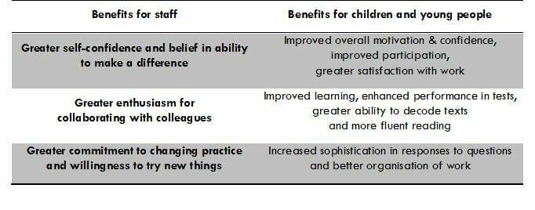 | 1
The Rosenshine steps will guide our pedagogy. These are built into Subject Handbooks and curriculum implementation. Examples include the following:  We use the ‘I do, we do, you do’ model to support Rosenshine. We will share good practice of this with staff.  Our ‘Do Nows’ are designed to connect new learning with prior learning. We will continue to use these in all lessons to support the schema. | Principles of Instruction- Borak Rosenshine 2012  Rosenshine’s Principles in Action, Tom Sherrington 2019 | 1
Embedding effective formative assessment.  Continued sharing of good practice around effective questioning, continued CPD and coaching on effective questioning.  We will use Mini Whiteboards in all classrooms to ensure that we deepen learning and check understanding systematically. We will continue to offer regular CPD to staff on the effective use of Mini Whiteboards. We will also ensure that all teachers in school are coached on their formative assessment skills. (Objective 3 of the Individual Growth Plan).  Routine QA that offers constructive feedback is built into the calendar termly. | Hattie 2012 said that the key to quality questioning is the type of questions and how they are used.  Rosenshine 2012 encourages teachers to ‘ask a large number of questions and check the responses of all students.  ‘Teachers use questioning for two main- and quite distinct- purposes: to promote students’ thinking, and to assess it’.  ‘The Great Teaching Toolkit’, Evidence Based Education.  Hattie (2003) Teachers Make a Difference.  Research briefing National Research Development Centre  Dylan William and Siobhan (2011), Embedded Formative Assessment. | 1
Building on our rich and robust curriculum:  We want to widen our curriculum so that it offers insight into how working-class people have achieved great things, we want this to inspire our PP students within the learning context. | We know from David Steiner’s Curriculum Research that ‘curriculum is a critical factor in student academic success. A comprehensive, content-rich curriculum is a common feature of academically high-performing countries’  Equity in Education Lee Elliot Major (2023): Enriching and inspiring PP students through the Curriculum. | 1
Reading Intervention  Early diagnostic testing of students in Year 7 to identify struggling readers. Students placed in appropriate interventions within the five-tier programme to meet their reading needs. Rapid progress is monitored through termly testing and regular QA  Whole School  Developing a love for reading  Form time readers in Year 7, Year 8, Year 9 and Year 10. 30 minutes each week dedicated to shared reading in form time. Prosody modelled to support students in developing their own internal prosody, their reading fluency, word reading accuracy and comprehension.  Whole School – Supporting Struggling Readers across the curriculum  Reading strategies shared in CPD sessions are evident across the curriculum and can be seen in Curriculum Handbooks, lesson visits, work scrutiny and student voice.  Struggling reader information, strategies and support is shared through the Struggling Readers Booklet. All staff aware of who their struggling readers are and how best to support them in their classroom  CPD on disciplinary literacy – EFF’s The Six Strands of Reading and Oracy must be evidenced in Curriculum Handbooks, lesson visits, student voice  English Department  Weekly reading lessons for all students in KS3. New format to reading lessons to ensure explicit teaching of discrete reading skills. Explicit teaching of vocabulary to support the acquisition of new vocabulary and reading comprehension tasks at the start of every reading lesson. Consistency of delivery is ensured through high quality reading booklets.  English staff support and monitor reading progress in weekly reading lessons. Specific focus on increasing the volume of reading which is monitored through Accelerated Reading Programme and promoted through the Word Millionaire Competition. SLT Literacy Lead monitors reading data and word counts shared twice every half term.  Monitor all reading data for their classes and put in place appropriate intervention where needed and offer referrals where there are concerns  Accountable reading in KS3 to support the reading of novels  KS4 weekly reading tasks as part of homework  Explicit teaching of subject specific vocabulary. Teaching of vocabulary carefully mapped into the curriculum. | Our Literacy Development Team works closely with the SEND Department to ensure the literacy needs of our students are identified and effectively targeted through the use of direct, explicit and systematic fluency, vocabulary and comprehension instruction. The 5 Tier Intervention programme (see below) has been designed using research and recommendations from the EFF’s ‘Improving Literacy in Secondary Schools’ and the influential work of Murphy and Murphy ‘Thinking Reading’.  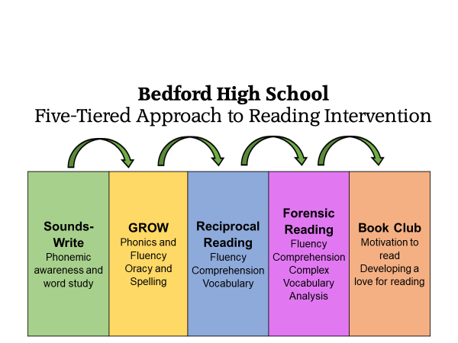  We recognise that literacy is the essential foundation of education and developing students’ competence for reading is one of the most effective ways to raise attainment. Research from EFF’s ‘Improving Literacy in Secondary Schools’ tells us that reading for pleasure is the single biggest factor in success in later life. Study after study has shown that those children who read for pleasure are the ones who are most likely to fulfil their ambitions. Therefore, our aim at Bedford is that every student, regardless of their starting point, becomes a fluent and confident reader who understands the importance of reading on their future lives.  EFF’s Six Strands of Reading used to inform whole school CPD | 2

Targeted academic support (for example, tutoring, one-to-one support, structured interventions)
Budgeted cost: £ [insert amount]
Activity | Evidence that supports this approach | Challenge number(s) addressed
Reading intervention  In the first weeks of September, KS2 SATs data is used to identify students who may require reading support in KS3. KS2 SATs Reading 2024 data reveals that 65 students (27% of Year 7 cohort) have not achieved the expected standard in reading. 24 of these students are PP. This is in line with the national picture. Diagnostic testing is used to identify specific reading needs of these students. Every child who failed to reach expected standard in KS2 Reading undertakes a running record test and a Salford Reading Test to assess their word recognition, fluency and comprehension skills. Where necessary, a further Sounds-Write tested is conducted. Students are then tested through Renaissance Place’s Star Reading Programme. The data from this testing allows us to identify any further students who may require additional reading support. Once this process is completed, we have our Struggling Readers list and each student is placed into the appropriate reading intervention specifically designed to address their specific reading needs. All of these students then sit a further two reading tests to ensure we have an accurate reading age starting point which allows us to monitor their progress accurately.  The Sounds-Write programme is delivered by 2 qualified members of staff. Intervention time for Sounds-Write has increased in this academic to 3 hours weekly for those requiring urgent reading support. This will ensure rapid improvement for our weakest readers.  Students requiring the next stage of phonics learning will receive GROW intervention led by our Interventions Officer and our Literacy Manager. Training will be delivered to our new members of the Literacy Team in the first term to increase intervention expertise and capacity.  Reciprocal Reading is delivered by the Literacy Team and 4 trained LSAs and continues to be developed by the Literacy Manager and the Director of Learning overseeing reading intervention.  Forensic Reading was launched last year with a small cohort of students who have graduated from Reciprocal Reading. The capacity for delivering this intervention has increased this academic year with two new members of staff now fully trained.  Book clubs – once students have graduated to tier 5, students will join dedicated book clubs to develop a love for reading and continue on their reading journey. | Gorse Academy Trust – Forensic Reading  Murphy and Murphy ‘Thinking Reading’  EFF Improving Literacy in Secondary Schools  University of Durham study (2011)  Tullis & Goldstone (2020)  EEF T&L Toolkit Reading – very high impact for very low cost) | 2
Numeracy intervention

Wider strategies (for example, related to attendance, behaviour, wellbeing)
Budgeted cost: £ [insert amount]
Activity | Evidence that supports this approach | Challenge number(s) addressed
Support to enrich the Cultural and Social capital.
Attendance  RAP – Y11 linking attendance and attainment. Team around the cohort approach to ensure rapid intervention is implemented to improve attendance to school, preparation for assessments and attendance to exams.  RAP – Y10 to be introduced in HT2  Dedicated attendance staff linked to Y10 and Y11  EBSA officer appointed with a focus on <50% and those at risk of SA.  Reset Intervention  Increased capacity for  Early Help intervention | 2024 exam data evidenced a significant improvement to exam attendance. U codes were also dramatically reduced as a result.  EBSA interventions from 2024 led to a reduction in SA – lower than LA average.  2024 Early Help intervention helped to reduce the number of cases escalating to social care / enforcement.
Responsive Pastoral system which identifies barriers and relevant early intervention.  Individual action plans created for SEMH and PP students struggling to engage at school via PiF meetings.  Triage Room used as an effective ‘regulation’ room for PP/SEND students who need it  Parent/Teacher working groups work to engage parents in working together, using the model from the cultural cohesion group in 2023.  The Pastoral in Focus meetings pinpoint the students who need extra support every fortnight with a focus on PP students every 8 weeks. These sessions also act as extra bespoke training for pastoral colleagues. GC did training on ‘Equity for the Under-resourced' on 11/11/24. This training focused on the types of barriers PP students can face and how we can support them.  Arts and wider extra-curricular promoted at various events.  Parental engagement action plan and linked LPPA work | EEF identify that good SEMH and behaviour intervention can impact progress by 4 months  SEMH intervention  Intervention to engage parents can result in up to 4 months accelerated progress for a student (EEF)  Equity in Education, Lee Elliot Major: The importance of recognising the barrier and putting the relevant intervention in place to support the student. These can be emerging barriers that require early intervention.  EEF’s research on the impact of arts education on overall achievement in other areas, accelerating progress by up to 3 months.  EEF cite that effective parental communication, and engagement can improve achievement by up to 4 months
Enrichment trips and events  Extra-curricular clubs promoted in key messages via form tutors each week, signposted on posters around school, and on the TV screens. In half term 2- there are over 100 club opportunities over a weekly period available.  Free/reduced cost musical instrument and singing lessons are provided for PP students.  All of our Year 7 students have taken part in a Sing Off during half term 2- where they came together as a year group to perform different songs in a singing competition.  Tickets for our annual Arts Shows are sent out to our PP families free of charge.  Year 7 students have a ‘SPIRIT Passport’ over Nov-Feb- to receive different levels of award (Bronze-Platinum). Criteria for the award includes attendance, punctuality, Class Charts, attendance to clubs and helping at home.  Our PP students are supported financially with our annual enrichment day and aspiration day trips. These include cultural trips to the museum/zoo/beach and to the museum/theatre/orchestra.  Students in all year groups take part in interform sporting activities in form time once a week over a term.  All Child organisation who are based in school are working with 30 of our Year 7 and 8 students and families on early intervention. 87% of these students are currently PP. This programme also included working with local partners such as Wigan Athletic, Commando Joes and Girls out Loud.  We have applied to be part of a scheme with Leigh Lepard's- Inspiring Change Programme to work with 12 of our Year 9 students.  All students complete a PD booklet once per week during Form. This enables them to celebrate their Classcharts behaviour points, attendance and successes and strengths. This also helps to inform pathways and next steps.  In our weekly ‘Key messages’, we are celebrating extra- curricular success stories in Form, Assemblies, Headteacher half termly bulletins, social media and on our Monitors around school.  Parents are also invited to send in success stories of their child termly. These often celebrate success that we are not always aware of.  Students with SEND/PP are involved in the School Games events- such as the Year 7 Transition event at Howe Bridge. | EEF’s research on the impact of arts education on overall achievement in other areas, accelerating progress by up to 3 months.  EEF- There is some evidence that involvement in extra-curricular sporting activities may increase pupil attendance and retention.  EEF- Planned extra-curricular activities which include short, regular, and structured teaching in literacy and mathematics (either tutoring or group teaching) as part of a sports programme, such as an after-school club or summer school, are more likely to offer academic benefits than sporting activities alone.

Total budgeted cost: £ [insert sum of 3 amounts stated above]

Part B: Review of the previous academic year

Outcomes for disadvantaged pupils

The overall progress 8 outcome for the Class of 2024 indicated that PP students are progressing by half a grade less than Non-PP students. This is a trend over the last 3 years at Bedford High School. See table below.
 | Class of 2024 progress 8 | Class of 2023 progress 8 | Class of 2022 Progress 8
PP students | -0.54 | -1.19 | -0.61
Non PP Students | -0.10 | -0.51 | -0.19

However, the Progress 8 for English and Maths has narrowed. See table below.
 | Progress 8  2024 | Progress 8  2023 | Progress 8  2022
English  PP | -0.25 | -0.95 | -0.22
English  Non-PP | 0.32 | -0.08 | 0.12
Maths  PP | -0.55 | -1.15 | -0.31
Maths  Non-PP | -0.39 | -0.42 | -0.02

The table below shows the Attainment comparisons of PP and Non-PP students.
Attainment 8 shows a consistent gap over the last 3 years.
However, the Bedford attainment 8 scores of our disadvantaged students are well above the Local Authority average.
Attainment 8 | 2024 | 2023 | 2022
PP | 35.5 | 28.7 | 35.2
Non-PP | 46.3 | 40.8 | 46.3

5+ in Maths and Eng
Although this gap remains, Bedford’s % 5+ in English and Maths was the second highest in the Wigan borough for the Class of 2024.
 | 2024 | 2023 | 2022
PP | 30% | 18% | 31%
Non-PP | 46% | 32% | 46%

There are signs that gaps are narrowing for 4+ in English and Maths especially when comparing 2024 with 2023.
4+ in English and Maths
 | 2024 | 2023 | 2022
PP | 50% | 31% | 55%
Non-PP | 66% | 68% | 69%

4+ in English
 | 2024 | 2023 | 2022
PP | 63% | 46% | 68%
Non-PP | 81% | 79% | 80%

4+in Maths
 | 2024 | 2023 | 2022
PP | 55% | 36% | 59%
Non-PP | 68% | 70% | 72%

Bedford High school has the best results for % students achieving Grades 4-9, 5-9 and 7-9 in the Wigan LA in Chemistry, Physics and Biology. It is 2nd highest for English Literature for Grades 7-9 and 4th place overall for attainment in History.

Reading review:
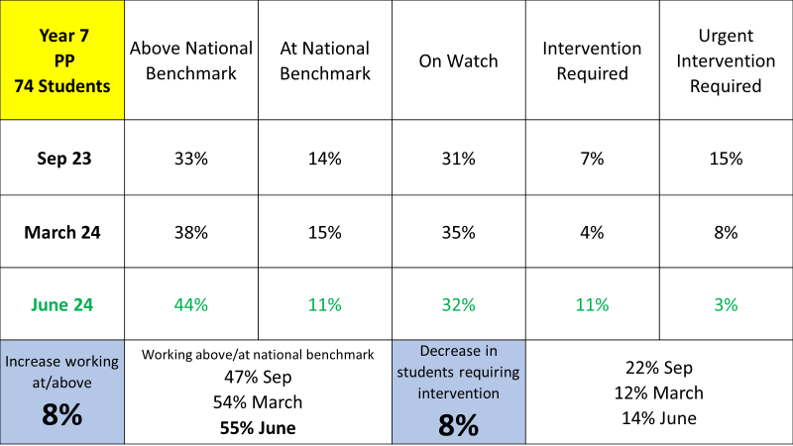
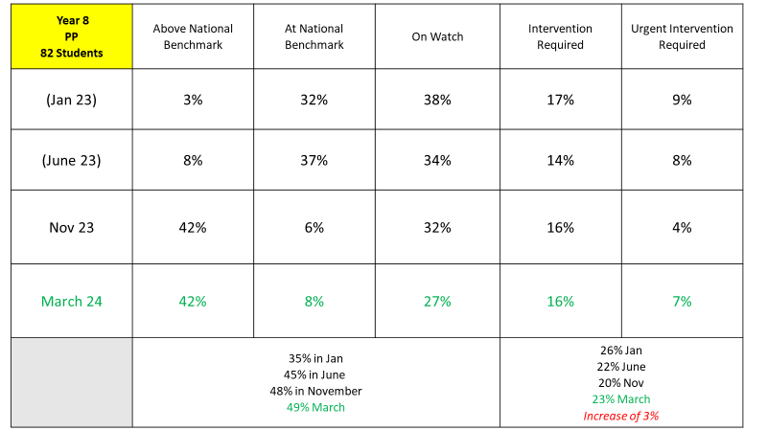
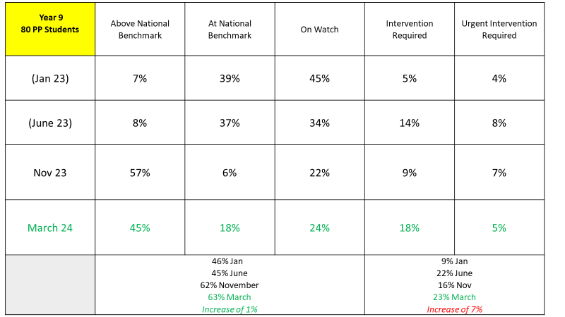Number of PP students requiring intervention in Year 8 and Year 9 has increased, but this is due to referrals from staff. There is now an awareness across the school of reading needs and how to identify struggling readers. The 5-Tier Reading Intervention Programme has only been running since Easter 2023. Early diagnostic testing would not have happened for these Year groups, hence a spike in those identified for intervention later in KS3.
PP students working at or above national benchmark has increased in each testing period.
Year 7 – 47% - 55%
Year 8 – 35% - 49%
Year 9 – 46% - 63%

Attendance review:
Attendance
Daily and weekly data scrutiny, attendance action plans, All Level 2 Early Helps now have an attendance focus. Many of the EH’s for PP students. The Early Help coordinator is now a permanent position, with this being expanded to the EBSA officer role in HT2.
HT1 Data
Whole School Attendance 2024-25 – HT2 (YTD)
Current Whole School Attendance Percentage | 93.19%
Unauthorised Absence as a percentage of total possible sessions | 3%
Persistent Absence (10% of sessions) | 23.6% | 267
Severe Absence (50% of sessions) | 2.1% | 24

Half Term 1 attendance percentage 2023-24 | 90.57
Half Term 1 attendance percentage 2022-23 | 92.2
Half Term 1 attendance percentage 2021-22 | 91.7

Attendance in State High Schools
Bedford High school | 93.19%
National Average (State Secondary Schools – FFT to 11/10/24) | 92.9%
LA Average | 92.9%

Overall attendance has remained roughly in line with national average, with encouraging signs of improving attendance during the last two weeks of half term.
At the start of HT1, through to week 3, we witnessed an increase in term time holidays. This has impacted the overall attendance figure. We have also had notification from parents regarding term time holidays for week 7 of HT1.
The LA average is 92.9% which shows we are roughly in line with our local schools, and facing similar challenges, however we are significantly lower than the LA average in Y7, which is unusual for a Y7 cohort.
Overall attendance has improved year-on-year, with the gap to pre-covid figures narrowing.
Year Group | PP |  | Non-PP
 | Number of Students | Average Attendance | Number of Students | Average Attendance
Year 7 | 95 | 90.62 | 143 | 96.5
Year 8 | 75 | 87.98 | 148 | 96.4
Year 9 | 85 | 88.29 | 150 | 94.87
Year 10 | 84 | 87.65 | 136 | 93.53
Year 11 | 74 | 88.25 | 136 | 94.12
We continue to see gaps between disadvantaged and non-disadvantaged groups. These gaps are wider still when considering SEND students who are also pupil premium.
Y8 have the widest gap (8.42%), followed by Y9 (6.58%). Y7, Y10 and Y11 have similar gaps of just under 6%. During HT2 there will be a particular focus of SEND and PP combined.
Behaviour and routines review
Character Education
SPIRIT now fully rolled out as a full character education programme, with form time learning, rewards in place and display around school. Strive and Independence are capitalised upon with the Year 11 study programme and the KS3 Bistro time in form for standards.
Review of the provision the Aspirations Centre support, took place, with intervention tracking. 60% of students referred to the AC showed improvements in their mental wellbeing, whereas only 20% of students referred for internal respites improved, so a new Well-being Officer role has been created to further the impact of the meaningful work the AC did. To further support behaviour systems and attendance issues, the AC roles have been replaced as follows:
Triage Officer
Internal Exclusion Officer
Wellbeing Officer
EBSA Officer
Free Breakfast Club for all PP students continues to be funded.
Parental Engagement
Following work with parents around inclusion (via the Diversity panel in June 2023) and surveying with ‘you said, we did’ feedback, the school is now applying for an award in this Leading Parent Partnership and so an additional action plan will be devised to sit alongside the PP strategy. The award will focus on areas of development such as engaging hard-to-reach parents.
CEIAG & Student Aspirations
(NEET figures 2024 to be added here) The school continues to put health first; encouraging walking to school, healthy options in the bistro, and opportunities for physical (Race for Life) and mental (kindness initiatives, mindfulness) health. College tours are to be brought forward in 2023-24 to engage students at a younger age (Year 9) and all students follow the process of applying to college and producing a CV and personal statement by the end of the first term of Year 11.

Externally provided programmes
Please include the names of any non-DfE programmes that you used your pupil premium to fund in the previous academic year.
Programme | Provider
Leading Parent Partnership | Optimus

Service pupil premium funding (optional)
For schools that receive this funding, you may wish to provide the following information: How our service pupil premium allocation was spent last academic year
The impact of that spending on service pupil premium eligible pupils

Further information (optional)
Use this space to provide any further information about your pupil premium strategy. For example, about your strategy planning, implementation and evaluation, or other activity that you are delivering to support disadvantaged pupils that is not dependent on pupil premium funding.

